Revised OCT, 2015 (E)－3
LICENSED INLAND SEA PILOT
For LNG ｃarrier
Bound for MEGA
PILOT INFORMATION CARD
Bridge Resource Management Exchange With Pilot (s)

To the Master of Pilot 1 :
Pilot 2 :

For safe navigation of your vessel you are kindly requested to:
‐ confirm the pilotage plan on this card,
‐ keep a sharp lookout, Name of escort boat
‐ keep watching VHF on channel 16, and ①
‐ put a question whenever you acknowledge a discrepancy. ②
‐ fix position at proper interval. ③ for AKASHl T.R. only
Details of Passage Plan and relevant information
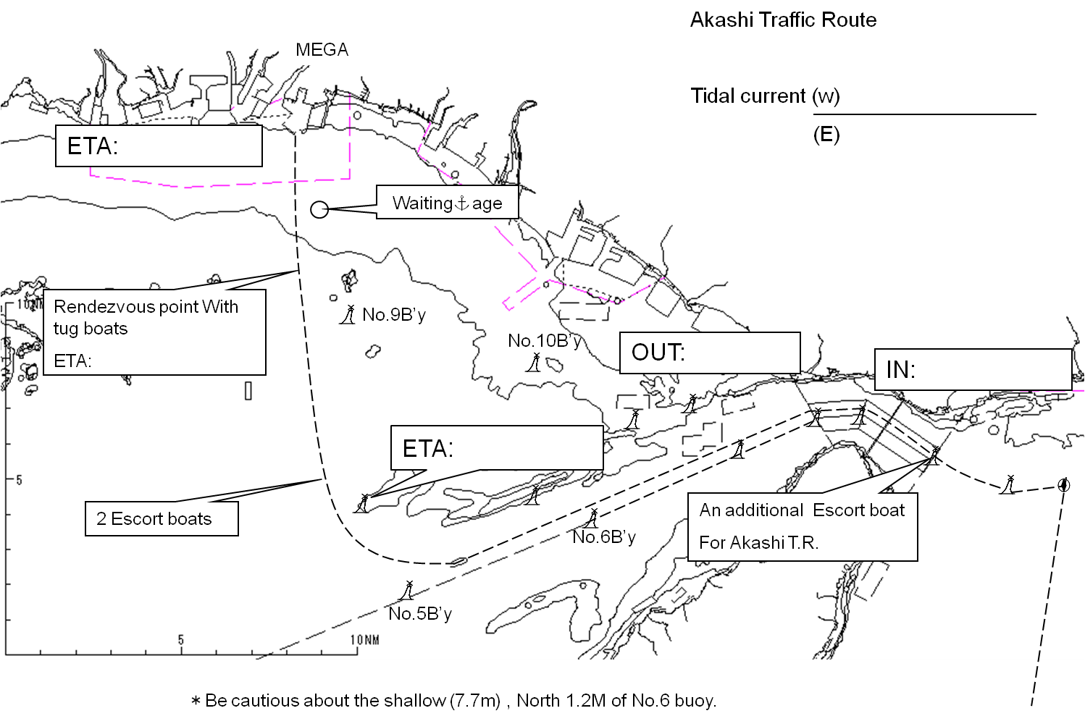
Other information

Tug boats arrangement A or B
①( ) PS ②( ) PS
③( ) PS ④( ) PS

〔Ａ〕 〔Ｂ〕

Safety measures for berthing
①Berthing operation should be suspended when average wind velocity exceeds 8m/sec and/or
visibility becomes less than l mile.
②In the above case, the ship should wait for recovery of weather conditions in Waiting
Anchorage (330ﾟ 3700m from Kami Shima L.H.).
③All tugs should be made fast to the ship before beginning final approach to the jetty.
④In approaching, the ship should be made parallel at about 100m off the jetty
and then be pushed up towards the jetty.
⑤A berthing speed should be under 25cm/sec at about
50m off the jetty.
⑥Final berthing speed should be kept below 8cm/sec.
⑦When touching fenders, the ship should be completely parallel or slightly at bow-in angle
to the jetty to prevent damage to the container platform.
⑧All the lines should be taken after the ship has reached to the jetty.
⑨Whenever let go tow line, please release and down respective tow line / Heaving Line safely
onto deck of tug.( After pointing at clear deck of tug.)
Berthing Plan of Mega LNG Terminal
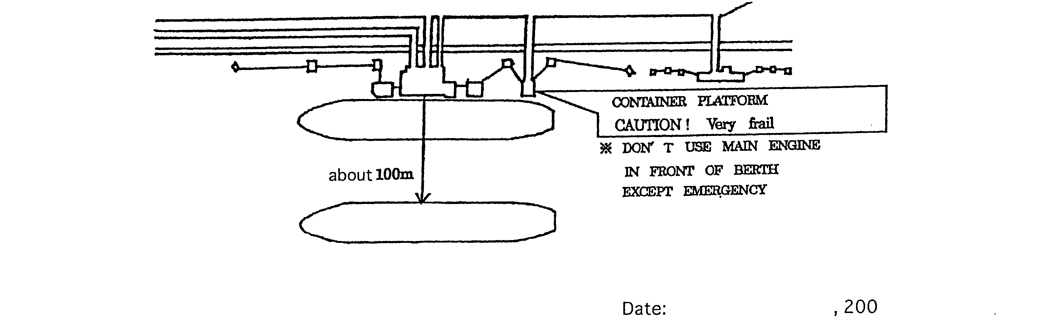

Date:

Master Inland Sea Pilot
During pilotage, particularly on long passage, circumstances may change which require an alteration from the Information provided. And it should be borne in mind that pilots have their own preferred ways of working which may lead to variations.

CHECK LIST UNDER PILOTAGE

DATE :

SHIP’S NAME :

Voy.No

- CONFIRMATION OF SHIP’S CONDITION & EQUIPMENT
MAIN ENGINE
SHIP’S DRAFT F： (M： ) A：
WHISTLE (IF AIR SUPPLY & LOCATION)
THRUSTER IF INSTALL
STEERING GEARS UNDER OPERATION (TWO UNITS)
GYRO COMPASS (INCLUDING ERROR)
VHF RADIO (CH-15,16 & 17)
NAVIGATIONAL LIGHTS & SHAPES
OTHER NAVIGATIONAL EQUIPMENT
- CONFIRMATION OF SHIP’S MANEUVERABILITY
- REQUEST TO MASTER
LOOKOUT & MONITOR OTHER SHIP’S MOVEMENT
FIX POSITION & REPORT PILOT IT AT PROPER TIMING
MONITOR DEVIATION FROM THE ORIGINAL ROUTE
CONFIRMATION & MONITOR PILOT’S INTENTION/ORDER IF ANY DOUBT
- SHOW/LOWER THE FLAGS & SHAPES
- PRE-NOTICE TO MASTER
REDUCTION SPEED (SEA→S/B) MINUTES
CHANGE FUEL IF NECESSARY MINUTES
THRUSTER TO USE MINUTES
STATION CREW (TUG LINE , ANCHOR , BERTHING ETC.) MINUTES
ASTERN TEST
6. SEA SPEED KTS RPM
7. EXCHANGE & CONFIRMATION OF
“PILOT CARD” AND “PILOT INFORMATION CARD”
- SELF ALCOHOL CHECK BY PILOTS
BREATH ALCOHOL CONCENTRATION MEASURED IS LESS THAN 0.15mg/l.

MASTER PILOT

