(E)－4
LICENSED INLAND SEA PILOT

For LNG Carrier
Sail from MEGA
PILOT INFORMATION CARD
Bridge Resource Management Exchange With Pilot (s)

To the Master of Pilot 1:

Pilot 2:
For safe navigation of your vessel, you are kindly requested to:
－confirm the pilotage plan on this card, Name of escort boat
－keep a sharp lookout, ①
－keep watching VHF on channel 16, and ②
－put a question whenever you acknowledge a discrepancy. ③ for AKASHI T.R. only
－fix position at proper interval.

Detail of Passage Plan and relevant information
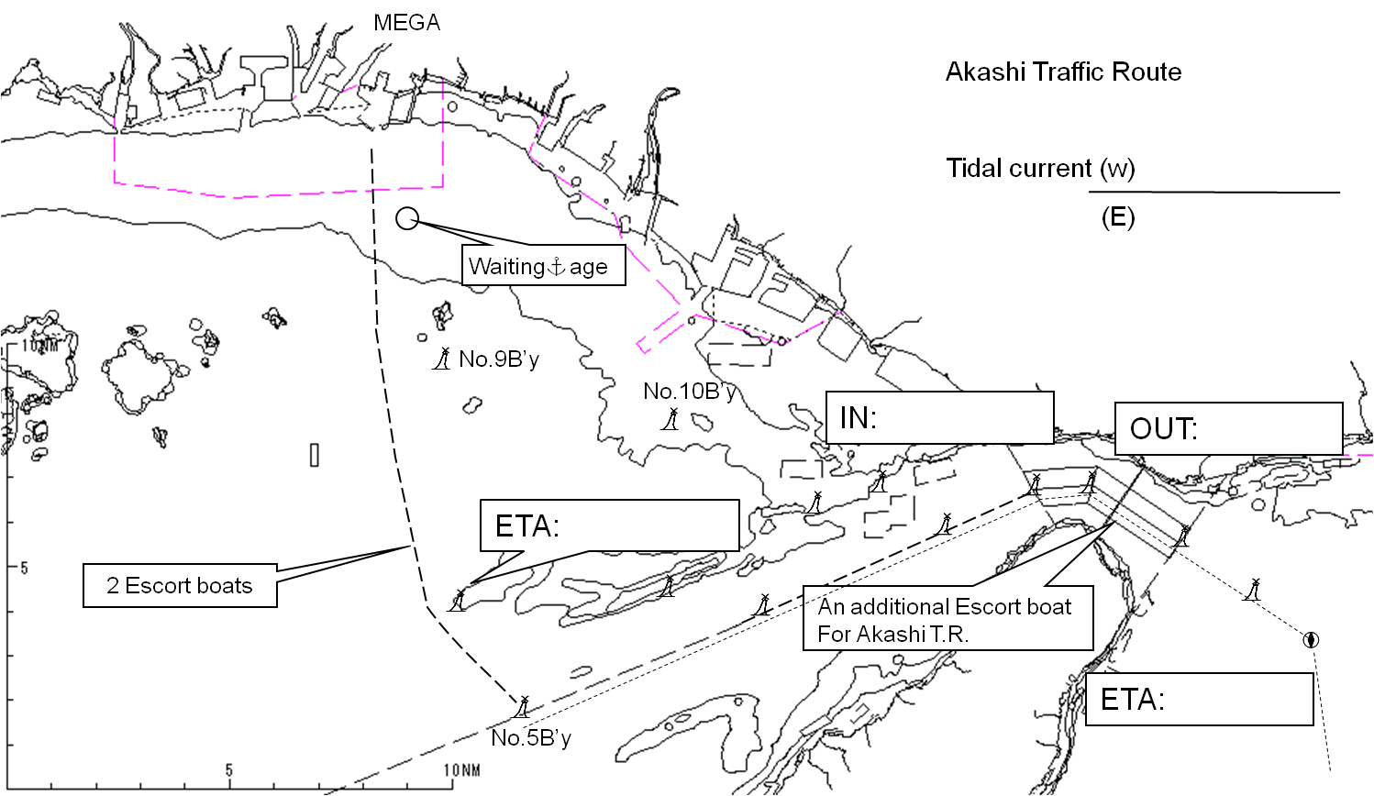
Other information

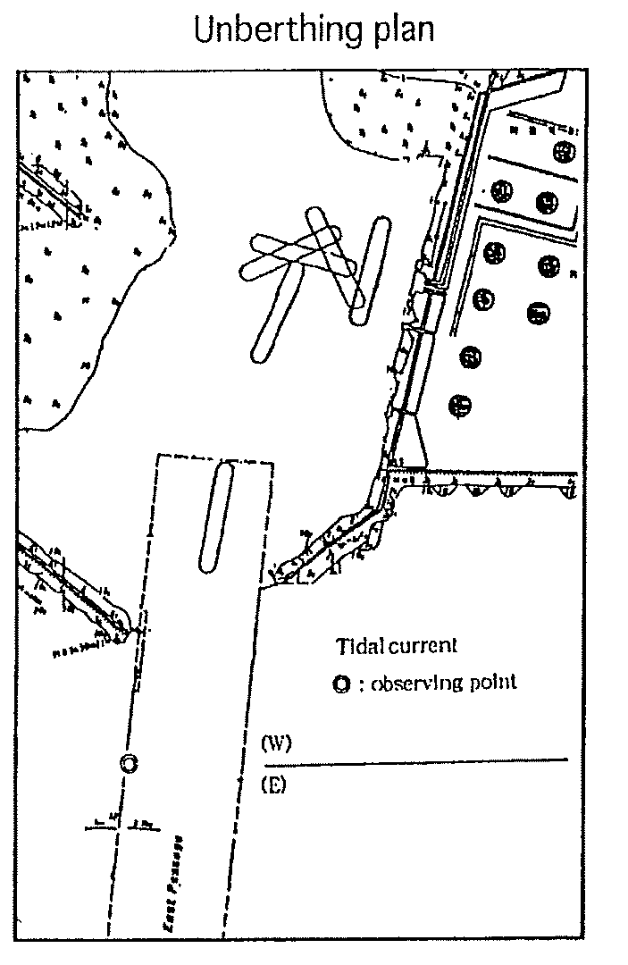
Tug boat arrangement
①( ) PS
②( ) PS
③( ) PS
④( ) PS





Safety measures for Unberthing

① Unberthing operation should be suspended when average wind velocity exceeds 8m/sec and/or
visibility becomes less than l mile.
② Make fast 2 tugs fore and aft on a tow line and push up to the berth together with amidships tug (no line).
③ Let go all shore lines, first head/stern lines, secondly breast lines and lastly spring lines.
④ Pull the ship by tugs bodily sideways and parallel with the berth, to about 100m off.
⑤ Then turn the ship round 180ﾟ anticlockwise, keeping the minimum distance of about 80m to the berth.
⑥ When the ships heading comes to between the breakwaters, stop turning and start proceeding with the engines and the rudder and then let go all tugs.
⑦ Increase the speed progressively so as to pass the breakwaters at about 5kts and to proceed through the
fairway at about 8kts in order to cope with cross current and/or wind.
⑧ 3 tugs will serve as escorts on her sides while the ship is transiting the fairway.
⑨ Whenever let go tow line, please release and down respective tow line / Heaving Line safely onto deck
of tug. ( After pointing at clear deck of tug. )

Plan of Mega LNG Terminal

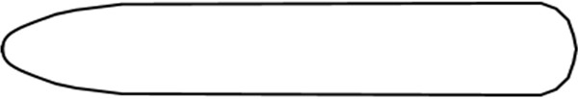
CONTAINER PLATFORM
CAUTION! Very frail
About 100m

Date:

Master Inland Sea Pilot
During pilotage, particularly on long passage, circumstances may change which require an alteration from

the information provided and it should be borne in mind that pilotｓ has their own preferred way of working
which may lead to variations.
CHECK LIST UNDER PILOTAGE

DATE :

SHIP’S NAME :

Voy.No

- CONFIRMATION OF SHIP’S CONDITION & EQUIPMENT
MAIN ENGINE
SHIP’S DRAFT F： (M： ) A：
WHISTLE (IF AIR SUPPLY & LOCATION)
THRUSTER IF INSTALL
STEERING GEARS UNDER OPERATION (TWO UNITS)
GYRO COMPASS (INCLUDING ERROR)
VHF RADIO (CH-15,16 & 17)
NAVIGATIONAL LIGHTS & SHAPES
OTHER NAVIGATIONAL EQUIPMENT
- CONFIRMATION OF SHIP’S MANEUVERABILITY
- REQUEST TO MASTER
LOOKOUT & MONITOR OTHER SHIP’S MOVEMENT
FIX POSITION & REPORT PILOT IT AT PROPER TIMING
MONITOR DEVIATION FROM THE ORIGINAL ROUTE
CONFIRMATION & MONITOR PILOT’S INTENTION/ORDER IF ANY DOUBT
- SHOW/LOWER THE FLAGS & SHAPES
- PRE-NOTICE TO MASTER
REDUCTION SPEED (SEA→S/B) MINUTES
CHANGE FUEL IF NECESSARY MINUTES
THRUSTER TO USE MINUTES
STATION CREW (TUG LINE , ANCHOR , BERTHING ETC.) MINUTES
ASTERN TEST
6. SEA SPEED KTS RPM
7. EXCHANGE & CONFIRMATION OF
“PILOT CARD” AND “PILOT INFORMATION CARD”
- SELF ALCOHOL CHECK BY PILOTS
BREATH ALCOHOL CONCENTRATION MEASURED IS LESS THAN 0.15mg/l.

MASTER PILOT

