(E)－7

LICENSED INLAND SEA PILOT
PILOT INFORMATION CARD
(WADA / ABOSHI)
Bridge Resource Management Exchange With Pilot (s)

To the Master of Pilot:
During pilotage, particularly on long passage, circumstances may change which require an alteration from
the information provided. And it should be borne in mind that a pilot has their own preferred way of working
which may lead to variations.
For safe navigation of your vessel, you are kindly requested to:
－confirm the pilotage plan on this card,
－keep a sharp lookout,
－keep watching VHF channel 16, and
－put a question whenever you find discrepancy.
－fix position at proper interval.

Detail of passage plan and relevant information

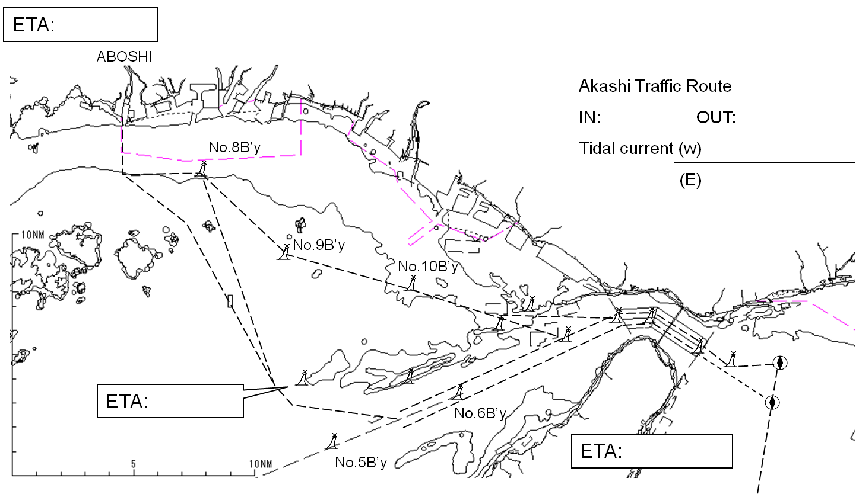

Tidal Height
( cm)
( cm)

Other Information

Tug boat arrangement
(① ) PS
(② ) PS
(③ ) PS

Date:

Master Inland Sea Pilot

CHECK LIST UNDER PILOTAGE

DATE :

SHIP’S NAME :

Voy.No

- CONFIRMATION OF SHIP’S CONDITION & EQUIPMENT
MAIN ENGINE
SHIP’S DRAFT F： (M： ) A：
WHISTLE (IF AIR SUPPLY & LOCATION)
THRUSTER IF INSTALL
STEERING GEARS UNDER OPERATION (TWO UNITS)
GYRO COMPASS (INCLUDING ERROR)
VHF RADIO (CH-15,16 & 17)
NAVIGATIONAL LIGHTS & SHAPES
OTHER NAVIGATIONAL EQUIPMENT
- CONFIRMATION OF SHIP’S MANEUVERABILITY
- REQUEST TO MASTER
LOOKOUT & MONITOR OTHER SHIP’S MOVEMENT
FIX POSITION & REPORT PILOT IT AT PROPER TIMING
MONITOR DEVIATION FROM THE ORIGINAL ROUTE
CONFIRMATION & MONITOR PILOT’S INTENTION/ORDER IF ANY DOUBT
- SHOW/LOWER THE FLAGS & SHAPES
- PRE-NOTICE TO MASTER
REDUCTION SPEED (SEA→S/B) MINUTES
CHANGE FUEL IF NECESSARY MINUTES
THRUSTER TO USE MINUTES
STATION CREW (TUG LINE , ANCHOR , BERTHING ETC.) MINUTES
ASTERN TEST
6. SEA SPEED KTS RPM
7. EXCHANGE & CONFIRMATION OF
“PILOT CARD” AND “PILOT INFORMATION CARD”
- SELF ALCOHOL CHECK BY PILOTS
BREATH ALCOHOL CONCENTRATION MEASURED IS LESS THAN 0.15mg/l.

MASTER PILOT

