〔Revised July.2018〕
(W)－1
LICENSED INLAND SEA PILOT
For LPG carrier bound
For NAMIKATA
PILOT INFORMATION CARD
Bridge Resource Management Exchange With Pilot (s)
To the Master of Pilot:

For safe navigation of your vessel, you are kindly requested to:
－confirm the pilotage plan on this card,
－keep a sharp lookout,
－keep watching VHF channel 16, and
－put a question whenever you find discrepancy.
－fix position proper interval.
Detail of passage plan and relevant information




The Safety Pledge Letter should be observed.
One escort Tug equipped with fire fighting apparatus should be employed from Iyonada No.9 buoy to the Namikata Terminal.

Other information:

Tug Boat Arrangement

① ( ) PS
② ( ) PS
③ ( ) PS
④ ( ) PS
Berthing Plan
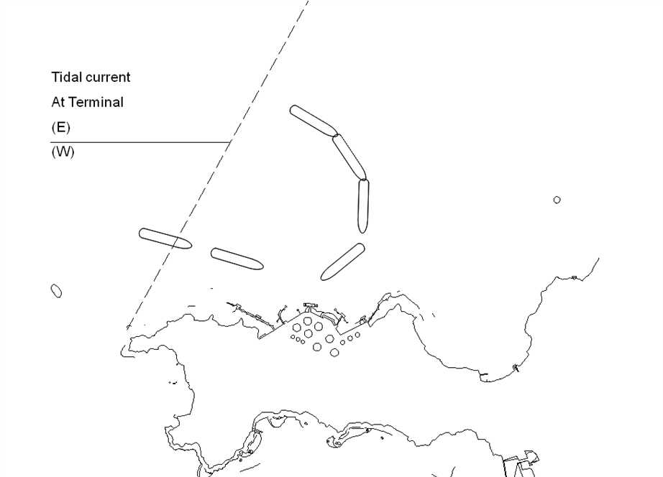

Safety measures for berthing
1 Berthing operation should be suspended when average wind velocity exceeds 8m/sec and/or
there is a risk of exceeding the maximum instantaneous wind speed of 12m/sec.
2 The ship should be made a complete and parallel stop at 100～150m off the jetty.
3 Final berthing speed should be kept below 10cm/sec.

Plan of Namikata terminal

Date:

Master Pilot

During pilotage, particularly on long passage, circumstances may change which require an alteration from the information provided. And it should be borne in mind that a pilot has their own preferred way of working which may lead variations.

CHECK LIST UNDER PILOTAGE

DATE :

SHIP’S NAME :

Voy.No

- CONFIRMATION OF SHIP’S CONDITION & EQUIPMENT
MAIN ENGINE
SHIP’S DRAFT F： (M： ) A：
WHISTLE (IF AIR SUPPLY & LOCATION)
THRUSTER IF INSTALL
STEERING GEARS UNDER OPERATION (TWO UNITS)
GYRO COMPASS (INCLUDING ERROR)
VHF RADIO (CH-15,16 & 17)
NAVIGATIONAL LIGHTS & SHAPES
OTHER NAVIGATIONAL EQUIPMENT
- CONFIRMATION OF SHIP’S MANEUVERABILITY
- REQUEST TO MASTER
LOOKOUT & MONITOR OTHER SHIP’S MOVEMENT
FIX POSITION & REPORT PILOT IT AT PROPER TIMING
MONITOR DEVIATION FROM THE ORIGINAL ROUTE
CONFIRMATION & MONITOR PILOT’S INTENTION/ORDER IF ANY DOUBT
- SHOW/LOWER THE FLAGS & SHAPES
- PRE-NOTICE TO MASTER
REDUCTION SPEED (SEA→S/B) MINUTES
CHANGE FUEL IF NECESSARY MINUTES
THRUSTER TO USE MINUTES
STATION CREW (TUG LINE , ANCHOR , BERTHING ETC.) MINUTES
ASTERN TEST
6. SEA SPEED KTS RPM
7. EXCHANGE & CONFIRMATION OF
“PILOT CARD” AND “PILOT INFORMATION CARD”
- SELF ALCOHOL CHECK BY PILOTS
BREATH ALCOHOL CONCENTRATION MEASURED IS LESS THAN 0.15mg/l.

MASTER PILOT

