(W)－2
ＲＥＶＩＳＥＤ Apl. 2005
LICENSED INLAND SEA PILOT
For LNG carrier
Bound For YANAI
PILOT INFORMATION CARD
Ｂｒｉｄｇｅ Ｒｅｓｏｕｒｃｅ Ｍａｎａｇｅｍｅｎｔ Ｅｘｃｈａｎｇｅ Ｗｉｔｈ Ｐｉｌｏｔ（ｓ）
To the Master of Pilot:
H’r Pilot:
For safe navigation of your vessel, you are kindly requested to:
－confirm the pilotage plan on this card,
－keep a sharp lookout,
－keep watching VHF channel 16, and
－put a question whenever you find discrepancy.
－fix position proper interval.
Details of passage plan and relevant information.

The Safety Pledge Letter should be observed.




Other information

Berthing plan
Tug boats arrangement
①( ) PS
②( ) PS
③( ) PS
④( ) PS

Safety Measures for berthing
① Berthing operation should be suspended when wind velocity exceeds 10m/sec and/or
visibility becomes less than 1 mile.
② All tugs should be made fast to the ship before beginning final approach to the jetty.
③ The ship should be made a complete and parallel stop 150－200m off the jetty.
④ Final berthing speed should be kept below 5cm/sec.
⑤ Getting alongside the berth, spring lines, fore and aft each, should be taken first by line boats.

Plan of Yanai LNG Terminal

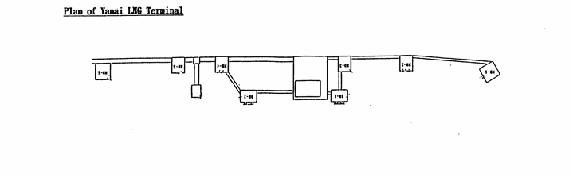

Date:

Master Inland Sea Pilot

During pilotage, particularly on long passage, circumstances may change which require an alteration
from the information provided. And it should be borne in mind that a pilot has their own preferred
way of working which may lead to variations.

CHECK LIST UNDER PILOTAGE

DATE :

SHIP’S NAME :

Voy.No

- CONFIRMATION OF SHIP’S CONDITION & EQUIPMENT
MAIN ENGINE
SHIP’S DRAFT F： (M： ) A：
WHISTLE (IF AIR SUPPLY & LOCATION)
THRUSTER IF INSTALL
STEERING GEARS UNDER OPERATION (TWO UNITS)
GYRO COMPASS (INCLUDING ERROR)
VHF RADIO (CH-15,16 & 17)
NAVIGATIONAL LIGHTS & SHAPES
OTHER NAVIGATIONAL EQUIPMENT
- CONFIRMATION OF SHIP’S MANEUVERABILITY
- REQUEST TO MASTER
LOOKOUT & MONITOR OTHER SHIP’S MOVEMENT
FIX POSITION & REPORT PILOT IT AT PROPER TIMING
MONITOR DEVIATION FROM THE ORIGINAL ROUTE
CONFIRMATION & MONITOR PILOT’S INTENTION/ORDER IF ANY DOUBT
- SHOW/LOWER THE FLAGS & SHAPES
- PRE-NOTICE TO MASTER
REDUCTION SPEED (SEA→S/B) MINUTES
CHANGE FUEL IF NECESSARY MINUTES
THRUSTER TO USE MINUTES
STATION CREW (TUG LINE , ANCHOR , BERTHING ETC.) MINUTES
ASTERN TEST
6. SEA SPEED KTS RPM
7. EXCHANGE & CONFIRMATION OF
“PILOT CARD” AND “PILOT INFORMATION CARD”
- SELF ALCOHOL CHECK BY PILOTS
BREATH ALCOHOL CONCENTRATION MEASURED IS LESS THAN 0.15mg/l.

MASTER PILOT

