(W)－４
ＲＥＶＩＳＥＤ Mar. 2009
LICENSED INLAND SEA PILOT
For LNG carrier
Bound For OITA
PILOT INFORMATION CARD

Ｂｒｉｄｇｅ Ｒｅｓｏｕｒｃｅ Ｍａｎａｇｅｍｅｎｔ Ｅｘｃｈａｎｇｅ Ｗｉｔｈ Ｐｉｌｏｔ（ｓ）

To the Master of Pilot:
H’r Pilot:
For safe navigation of your vessel, you are kindly requested to:
－confirm the pilotage plan on this card,
－keep a sharp lookout,
－keep watching VHF channel 16, and
－put a question whenever you find discrepancy.
－fix position proper interval.
Details of passage plan and relevant information.




The Safety Pledge Letter should be observed.
One escort boat should be employed from
Seki Saki pilot station to Oita LNG Terminal.

Other information

Berthing plan
Tug boats arrangement
①( ) PS
②( ) PS
③( ) PS
④( ) PS

Safety Measures for berthing
① Berthing operation should be suspended when wind velocity exceeds 10m/sec and/or visibility
becomes less than 1 mile.
② In case of the above, the ship should wait for recovery of weather conditions outside the Inland Sea.
③ All tugs should be made fast to the ship before beginning final approach to the Jetty.
④ The ship should be kept parallel against the Jetty 150m~200m off the Jetty.
⑤ The ship should be approached with parallel to the Jetty by Tugs and confirm berthing speed less than 10cm/sec at 20m~30m off the Jetty.
⑥ Final berthing speed should be kept below 5cm/sec at the best effort.
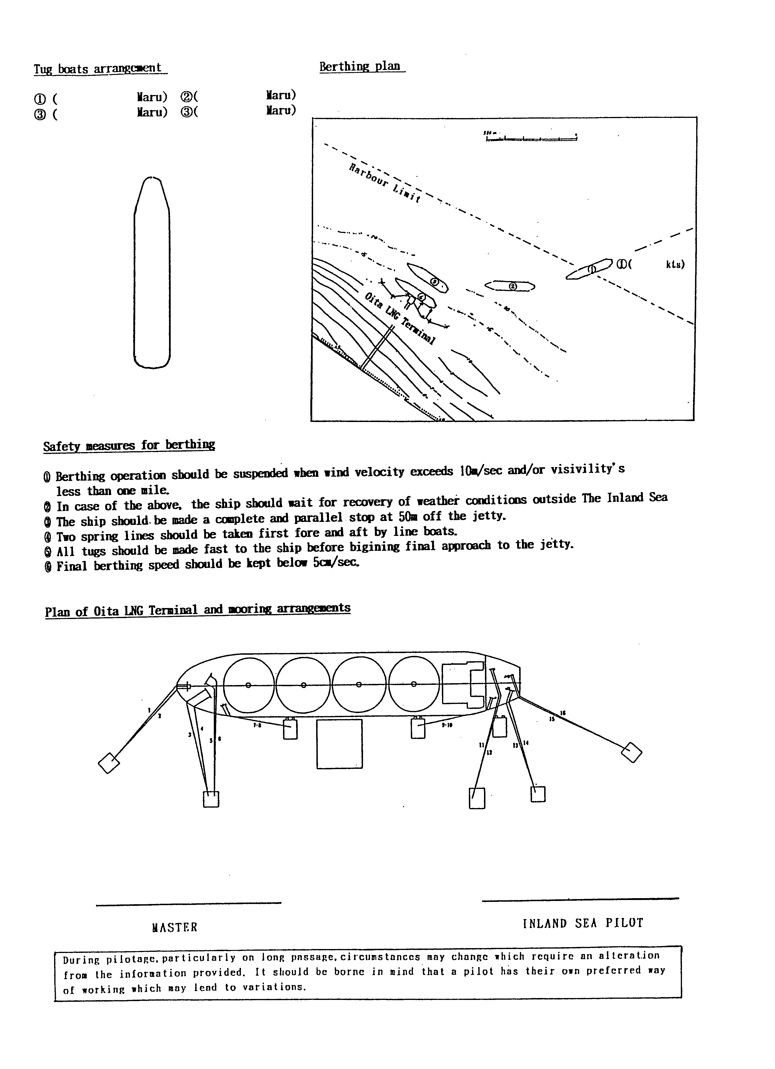
⑦ First rope should be aft spring after ship on fenders. Fore spring is brought by line boat.
Plan of Oita LNG Terminal and mooring arrangements

Date:
During pilotage, particularly on long passage, circumstances may change which require an alteration
From the information provided. And it should be borne in mind that a pilot has their own preferred way
of working which may lead to variations.

Master Inland Sea Pilot

CHECK LIST UNDER PILOTAGE

DATE :

SHIP’S NAME :

Voy.No

- CONFIRMATION OF SHIP’S CONDITION & EQUIPMENT
MAIN ENGINE
SHIP’S DRAFT F： (M： ) A：
WHISTLE (IF AIR SUPPLY & LOCATION)
THRUSTER IF INSTALL
STEERING GEARS UNDER OPERATION (TWO UNITS)
GYRO COMPASS (INCLUDING ERROR)
VHF RADIO (CH-15,16 & 17)
NAVIGATIONAL LIGHTS & SHAPES
OTHER NAVIGATIONAL EQUIPMENT
- CONFIRMATION OF SHIP’S MANEUVERABILITY
- REQUEST TO MASTER
LOOKOUT & MONITOR OTHER SHIP’S MOVEMENT
FIX POSITION & REPORT PILOT IT AT PROPER TIMING
MONITOR DEVIATION FROM THE ORIGINAL ROUTE
CONFIRMATION & MONITOR PILOT’S INTENTION/ORDER IF ANY DOUBT
- SHOW/LOWER THE FLAGS & SHAPES
- PRE-NOTICE TO MASTER
REDUCTION SPEED (SEA→S/B) MINUTES
CHANGE FUEL IF NECESSARY MINUTES
THRUSTER TO USE MINUTES
STATION CREW (TUG LINE , ANCHOR , BERTHING ETC.) MINUTES
ASTERN TEST
6. SEA SPEED KTS RPM
7. EXCHANGE & CONFIRMATION OF
“PILOT CARD” AND “PILOT INFORMATION CARD”
- SELF ALCOHOL CHECK BY PILOTS
BREATH ALCOHOL CONCENTRATION MEASURED IS LESS THAN 0.15mg/l.

MASTER PILOT

