(W)－5
For LPG carrier
bound For OITA
LICENSED INLAND SEA PILOT
PILOT INFORMATION CARD
Ｂｒｉｄｇｅ Ｒｅｓｏｕｒｃｅ Ｍａｎａｇｅｍｅｎｔ Ｅｘｃｈａｎｇｅ Ｗｉｔｈ Ｐｉｌｏｔ（ｓ）

To the Master of Pilot:

For safe navigation of your vessel, you are kindly requested to:
－confirm the pilotage plan on this card,
－keep a sharp lookout,
－keep watching VHF channel 16, and
－put a question whenever you find discrepancy.
－fix position proper interval.
Detail of passage plan and relevant information


The Safety Pledge Letter should be observed.
One escort boat should be employed from North
Of TAKASHIMA to Kyobigaiko LPG Terminal.

Other information：

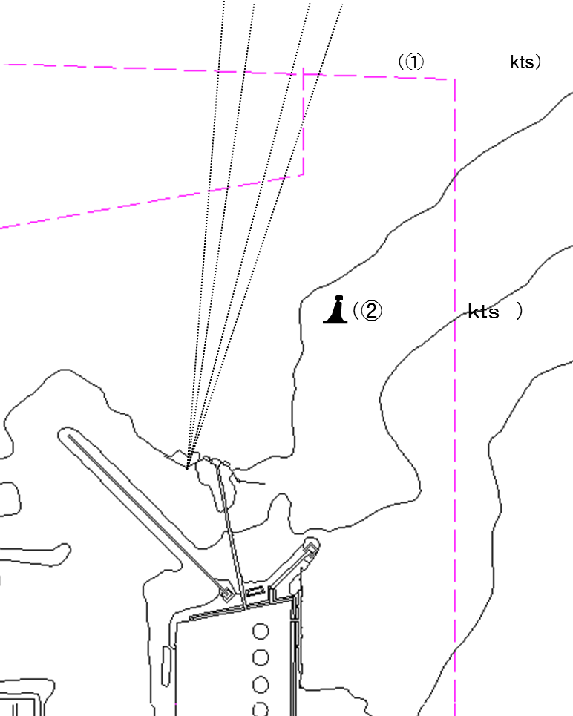
Tug boats arrangement

① ( ) PS
② ( ) PS
③ ( ) PS
④ ( ) PS

Berthing Plan

Safety measures for berthing
① The ship should be made a complete and parallel stop at 100m~150m off the jetty.
② Final berthing speed should be kept below 10cm/sec.

Plan of Oita kyobigaiko LPG Terminal and mooring arrangements

Date:

Master Inland Sea Pilot

During pilotage, particularly on long passage, circumstances may change which require an alteration
from the information provided. And it should be borne in mind that a pilot has their own preferred way of
working which may lead to variations.

CHECK LIST UNDER PILOTAGE

DATE :

SHIP’S NAME :

Voy.No

- CONFIRMATION OF SHIP’S CONDITION & EQUIPMENT
MAIN ENGINE
SHIP’S DRAFT F： (M： ) A：
WHISTLE (IF AIR SUPPLY & LOCATION)
THRUSTER IF INSTALL
STEERING GEARS UNDER OPERATION (TWO UNITS)
GYRO COMPASS (INCLUDING ERROR)
VHF RADIO (CH-15,16 & 17)
NAVIGATIONAL LIGHTS & SHAPES
OTHER NAVIGATIONAL EQUIPMENT
- CONFIRMATION OF SHIP’S MANEUVERABILITY
- REQUEST TO MASTER
LOOKOUT & MONITOR OTHER SHIP’S MOVEMENT
FIX POSITION & REPORT PILOT IT AT PROPER TIMING
MONITOR DEVIATION FROM THE ORIGINAL ROUTE
CONFIRMATION & MONITOR PILOT’S INTENTION/ORDER IF ANY DOUBT
- SHOW/LOWER THE FLAGS & SHAPES
- PRE-NOTICE TO MASTER
REDUCTION SPEED (SEA→S/B) MINUTES
CHANGE FUEL IF NECESSARY MINUTES
THRUSTER TO USE MINUTES
STATION CREW (TUG LINE , ANCHOR , BERTHING ETC.) MINUTES
ASTERN TEST
6. SEA SPEED KTS RPM
7. EXCHANGE & CONFIRMATION OF
“PILOT CARD” AND “PILOT INFORMATION CARD”
- SELF ALCOHOL CHECK BY PILOTS
BREATH ALCOHOL CONCENTRATION MEASURED IS LESS THAN 0.15mg/l.

MASTER PILOT

