〔Revised Oct .2015〕 (W)－6
LICENSED INLAND SEA PILOT
For VLCC bound
For OITA

PILOT INFORMATION CARD
Bridge Resource Management Exchange With Pilot(s)

To the Master of Pilot:

H’r Pilot:
For safe navigation of your vessel, you are kindly requested to:
－confirm the pilotage plan on this card,
－keep a sharp lookout,
－keep watching VHF channel 16, and
－put a question whenever you find discrepancy.
－fix position proper interval.
Detail of passage plan and relevant information
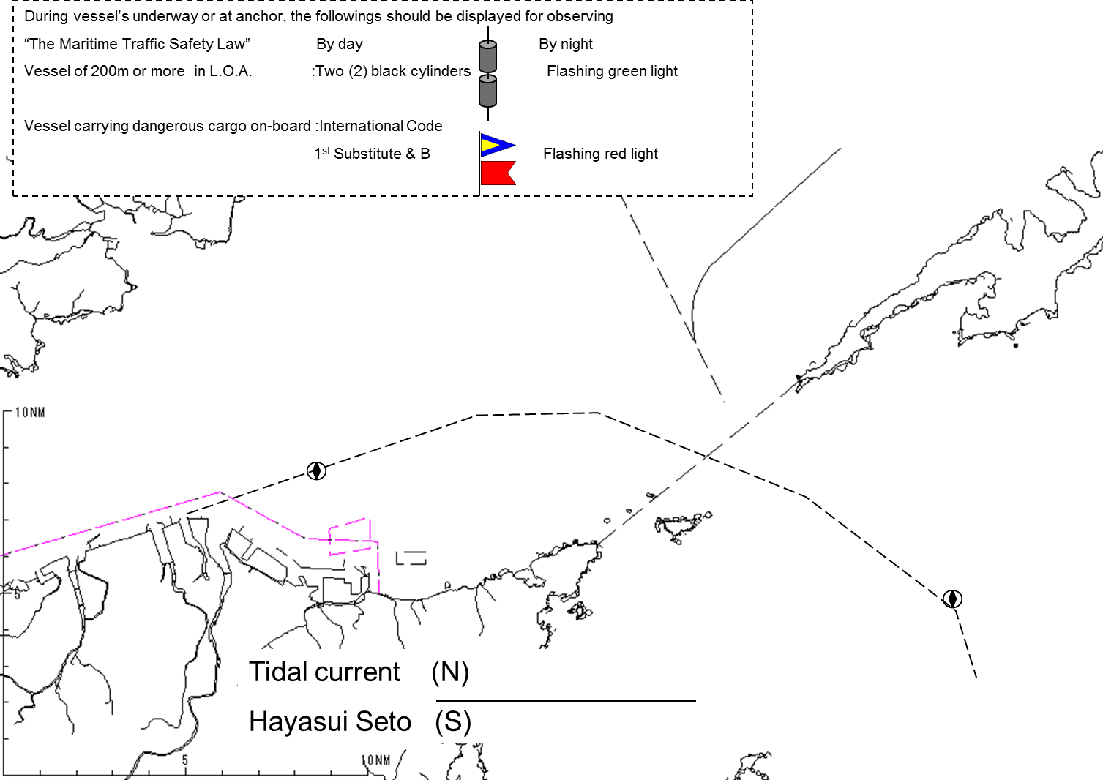
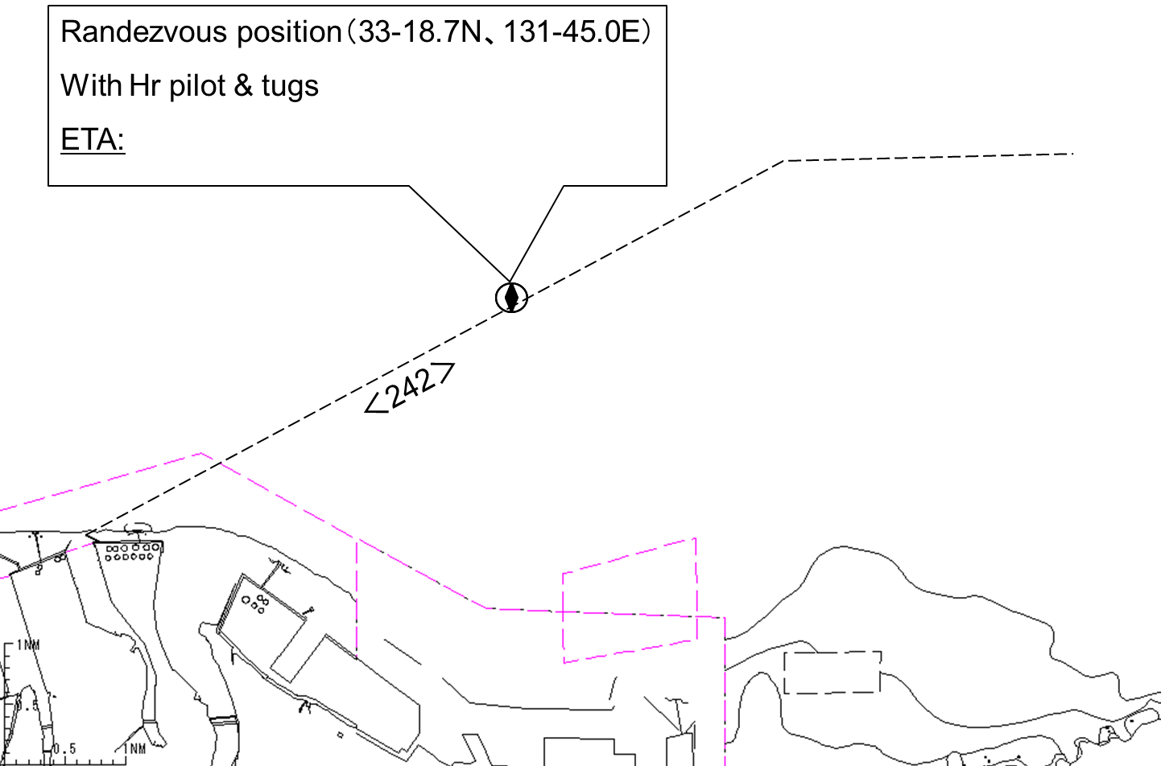

Other information

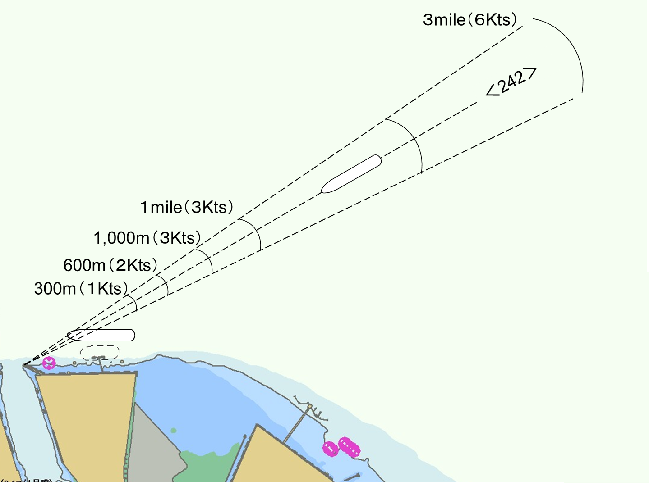

Tug boats arrangement
①( ) PS
②( ) PS
③( ) PS
④( ) PS
⑤( ) PS
Berthing Plan

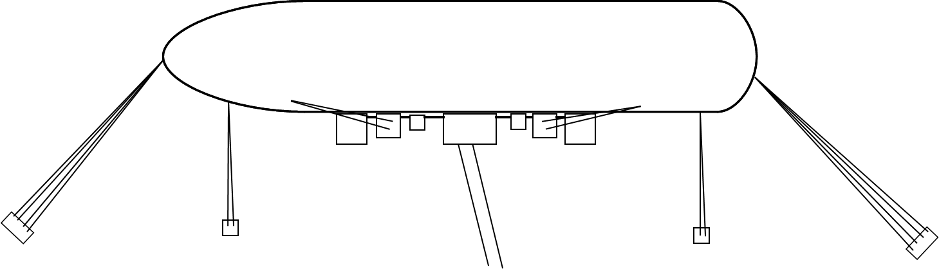

Safety measures for berthing
① Approaching course should be ＜242＞. (The heading mark is Oita Tsurusaki East Breakwater Lighthouse.)
② Ship speed should be as shown in the figure of the Berthing Plan. The tug shall report the distance and the speed
to BM and the ship.
③ The ship should be made a complete and parallel stop at 300m off the jetty.
④ Berthing speed should be as follows.
200m off the jetty ⇒ 15cm/sec or less
100m 〃 ⇒ 10cm/sec or less
30m 〃 ⇒ 5cm/sec or less
⑤ Final berthing speed should be kept less than 5cm/sec.

Plan of oil terminal No.1 and mooring arrangements.

Date:

Master Inland Sea Pilot
During pilotage, particularly on long passage, circumstances may change which require an alteration from the information provided. And it should be borne in mind that a pilot has their own preferred way of working which may lead to variations.

CHECK LIST UNDER PILOTAGE

DATE :

SHIP’S NAME :

Voy.No

- CONFIRMATION OF SHIP’S CONDITION & EQUIPMENT
MAIN ENGINE
SHIP’S DRAFT F： (M： ) A：
WHISTLE (IF AIR SUPPLY & LOCATION)
THRUSTER IF INSTALL
STEERING GEARS UNDER OPERATION (TWO UNITS)
GYRO COMPASS (INCLUDING ERROR)
VHF RADIO (CH-15,16 & 17)
NAVIGATIONAL LIGHTS & SHAPES
OTHER NAVIGATIONAL EQUIPMENT
- CONFIRMATION OF SHIP’S MANEUVERABILITY
- REQUEST TO MASTER
LOOKOUT & MONITOR OTHER SHIP’S MOVEMENT
FIX POSITION & REPORT PILOT IT AT PROPER TIMING
MONITOR DEVIATION FROM THE ORIGINAL ROUTE
CONFIRMATION & MONITOR PILOT’S INTENTION/ORDER IF ANY DOUBT
- SHOW/LOWER THE FLAGS & SHAPES
- PRE-NOTICE TO MASTER
REDUCTION SPEED (SEA→S/B) MINUTES
CHANGE FUEL IF NECESSARY MINUTES
THRUSTER TO USE MINUTES
STATION CREW (TUG LINE , ANCHOR , BERTHING ETC.) MINUTES
ASTERN TEST
6. SEA SPEED KTS RPM
7. EXCHANGE & CONFIRMATION OF
“PILOT CARD” AND “PILOT INFORMATION CARD”
- SELF ALCOHOL CHECK BY PILOTS
BREATH ALCOHOL CONCENTRATION MEASURED IS LESS THAN 0.15mg/l.

MASTER PILOT

