(W)－5－（3)

For LPG carrier bound
For OITA
LICENSED INLAND SEA PILOT
PILOT INFORMATION CARD
Ｂｒｉｄｇｅ Ｒｅｓｏｕｒｃｅ Ｍａｎａｇｅｍｅｎｔ Ｅｘｃｈａｎｇｅ Ｗｉｔｈ Ｐｉｌｏｔ（ｓ）

To the Master of Pilot:

For safe navigation of your vessel, you are kindly requested to:
－confirm the pilotage plan on this card,
－keep a sharp lookout,
－keep watching VHF channel 16, and
－put a question whenever you find discrepancy.
－fix position proper interval.
Detail of passage plan and relevant information




Other information：

TUG BOATS ARRANGEMENT
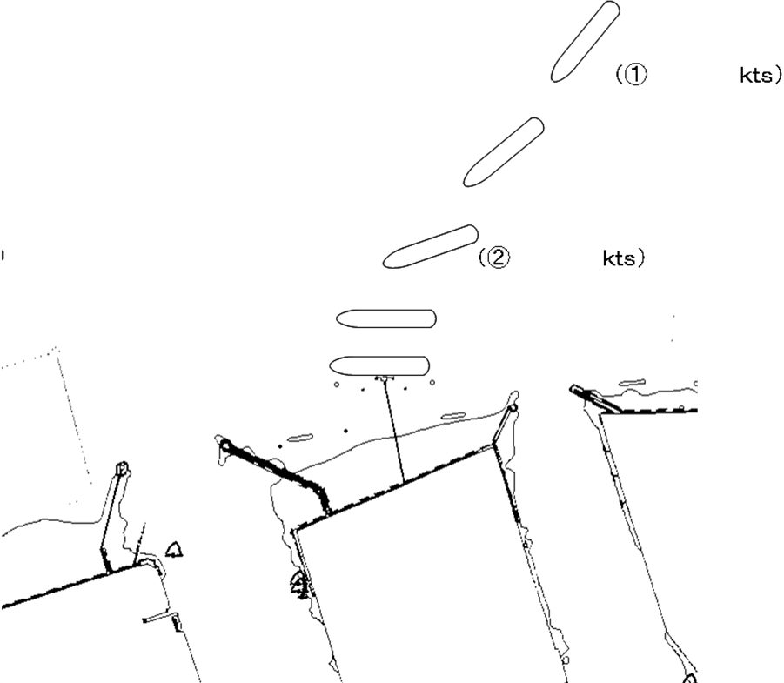
① （ ＰＳ）

② （ ＰＳ）

③ （ ＰＳ）

④ （ ＰＳ）

Safety measures for berthing
① The ship should be made a complete and parallel stop at 100m~150m off the jetty.
② Final berthing speed should be kept below 10cm/sec.
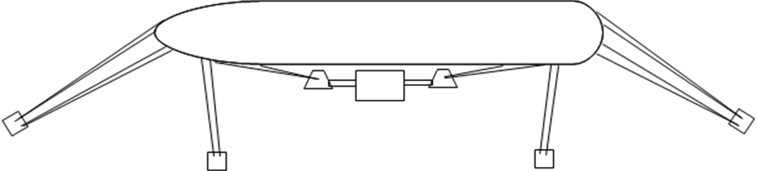

Date

Master Inland Sea Pilot
During pilotage, circumstances may change which require an alteration from the information provided. And it should be borne in mind that pilots have their own preferred ways of working which may lead to variation.

CHECK LIST UNDER PILOTAGE

DATE :

SHIP’S NAME :

Voy.No

- CONFIRMATION OF SHIP’S CONDITION & EQUIPMENT
MAIN ENGINE
SHIP’S DRAFT F： (M： ) A：
WHISTLE (IF AIR SUPPLY & LOCATION)
THRUSTER IF INSTALL
STEERING GEARS UNDER OPERATION (TWO UNITS)
GYRO COMPASS (INCLUDING ERROR)
VHF RADIO (CH-15,16 & 17)
NAVIGATIONAL LIGHTS & SHAPES
OTHER NAVIGATIONAL EQUIPMENT
- CONFIRMATION OF SHIP’S MANEUVERABILITY
- REQUEST TO MASTER
LOOKOUT & MONITOR OTHER SHIP’S MOVEMENT
FIX POSITION & REPORT PILOT IT AT PROPER TIMING
MONITOR DEVIATION FROM THE ORIGINAL ROUTE
CONFIRMATION & MONITOR PILOT’S INTENTION/ORDER IF ANY DOUBT
- SHOW/LOWER THE FLAGS & SHAPES
- PRE-NOTICE TO MASTER
REDUCTION SPEED (SEA→S/B) MINUTES
CHANGE FUEL IF NECESSARY MINUTES
THRUSTER TO USE MINUTES
STATION CREW (TUG LINE , ANCHOR , BERTHING ETC.) MINUTES
ASTERN TEST
6. SEA SPEED KTS RPM
7. EXCHANGE & CONFIRMATION OF
“PILOT CARD” AND “PILOT INFORMATION CARD”
- SELF ALCOHOL CHECK BY PILOTS
BREATH ALCOHOL CONCENTRATION MEASURED IS LESS THAN 0.15mg/l.

MASTER PILOT

