Revised Oct. 2016
(Ｍ)－12

Leaving From ／ Bound For

LICENSED INLAND SEA PILOT
PILOT INFORMATION CARD
Bridge Resource Management Exchange With Pilot (s)

To the Master of Pilot 1:
Pilot 2:
For safe navigation of your vessel, you are kindly requested to:
－confirm the pilotage plan on this card,
－keep a sharp lookout,
－keep watching VHF channel 16, and
－put a question whenever you find discrepancy.
－fix position proper interval.
Detail of passage plan and relevant information

SCHEDULE TRAFFIC ROUTE ESCORT BOAT TIDAL CURRENT
(IN) : (OUT) AKASHI TSURUSHIMA
AKASHI
( ) ( ) ( ) (WNW ) (NE )
BISAN EAST （ESE） (SW)
( ) ( ) ( )
BISAN NORTH BISAN HAYASUI
( ) ( ) ( )
MIZUSHIMA (W) (N)
( ) ( ) ( ) (E) (S)
BISAN SOUTH
( ) ( ) ( ) KURUSHIMA KANMON
KURUSHIMA
( ) ( ) ( ) (S) (W)
(N) (E)
Other information:
In case of a huge vessel 250m or more in length, one escort boat should be employed for passing Akashi Kaikyo,
Bisan Seto, Mizushima, and Kurushima kaikyo Traffic Routes. (The Maritime Traffic Safety Law)
One escort boat will be employed for a vessel of 200m～250m in length to pass Akashi Kaikyo and/or Bisan Seto
And Mizushima Traffic Routes in special fishing season. (voluntary safe measure)
≪Port of UNO (NAOSHIMA) ≫
Unberthing Arrangement Safety measures for unberthing
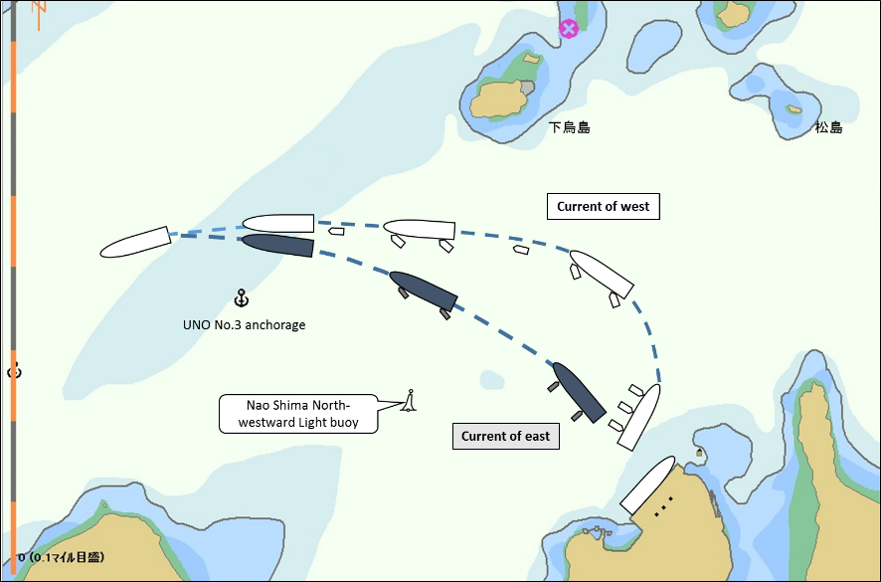
- Tugs’ lines should only be let go when she passes the buoy safely.
- Prevention of accident for the current of west, the ship must be turn around Nao Shima North-westward Light Buoy at a safe distance
and to be arranged 3tugs for un-berthing according to safety measures.



Tug boat Arrangement
(① ) PS
(② ) PS
(③ ) PS
Date:

Master Inland Sea Pilot
During pilotage, circumstances may change which require an alteration from the information provided. And it
should be borne in mind that pilots have their own preferred ways of working which may lead to variation.

CHECK LIST UNDER PILOTAGE

DATE :

SHIP’S NAME :

Voy.No

- CONFIRMATION OF SHIP’S CONDITION & EQUIPMENT
MAIN ENGINE
SHIP’S DRAFT F： (M： ) A：
WHISTLE (IF AIR SUPPLY & LOCATION)
THRUSTER IF INSTALL
STEERING GEARS UNDER OPERATION (TWO UNITS)
GYRO COMPASS (INCLUDING ERROR)
VHF RADIO (CH-15,16 & 17)
NAVIGATIONAL LIGHTS & SHAPES
OTHER NAVIGATIONAL EQUIPMENT
- CONFIRMATION OF SHIP’S MANEUVERABILITY
- REQUEST TO MASTER
LOOKOUT & MONITOR OTHER SHIP’S MOVEMENT
FIX POSITION & REPORT PILOT IT AT PROPER TIMING
MONITOR DEVIATION FROM THE ORIGINAL ROUTE
CONFIRMATION & MONITOR PILOT’S INTENTION/ORDER IF ANY DOUBT
- SHOW/LOWER THE FLAGS & SHAPES
- PRE-NOTICE TO MASTER
REDUCTION SPEED (SEA→S/B) MINUTES
CHANGE FUEL IF NECESSARY MINUTES
THRUSTER TO USE MINUTES
STATION CREW (TUG LINE , ANCHOR , BERTHING ETC.) MINUTES
ASTERN TEST
6. SEA SPEED KTS RPM
7. EXCHANGE & CONFIRMATION OF
“PILOT CARD” AND “PILOT INFORMATION CARD”
- SELF ALCOHOL CHECK BY PILOTS
BREATH ALCOHOL CONCENTRATION MEASURED IS LESS THAN 0.15mg/l.

MASTER PILOT

