HARBOR－3
LICENSED INLAND SEA PILOT
PILOT INFORMATION CARD
Bridge Resource Management Exchange With Pilot (s)

To the Master of
Pilot :

From To

Berthing / Unberthing Arrangement Tug Boat Arrangement

(① ) PS
(② ) PS
(③ ) PS
(④ ) PS

Tidal Height
H W ( ｃｍ)／ ( ｃｍ)
L W ( ｃｍ)／ ( ｃｍ)

Date:

Master Inland Sea Pilot

During pilotage, circumstances may change which require an alteration from the information provided. And it should be borne in mind that pilots have their own preferred ways of working which may lead to variation.
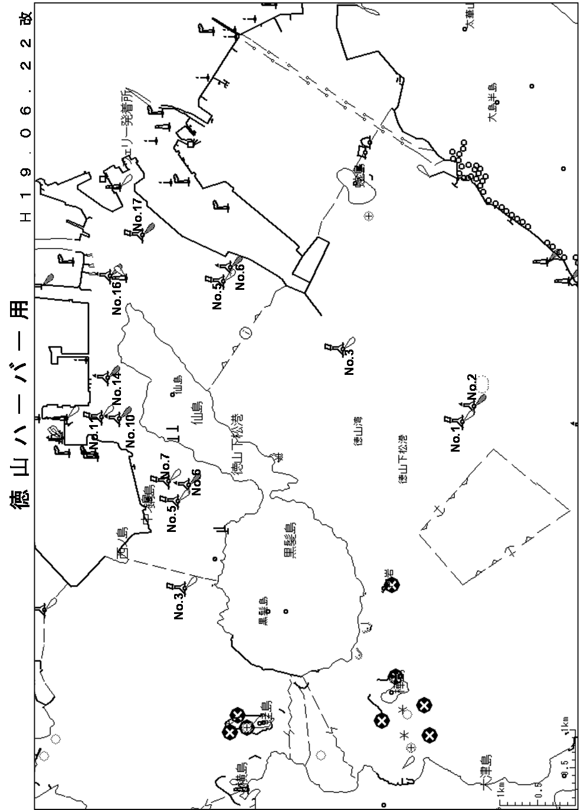

CHECK LIST UNDER PILOTAGE

DATE :

SHIP’S NAME :

Voy.No

- CONFIRMATION OF SHIP’S CONDITION & EQUIPMENT
MAIN ENGINE
SHIP’S DRAFT F： (M： ) A：
WHISTLE (IF AIR SUPPLY & LOCATION)
THRUSTER IF INSTALL
STEERING GEARS UNDER OPERATION (TWO UNITS)
GYRO COMPASS (INCLUDING ERROR)
VHF RADIO (CH-15,16 & 17)
NAVIGATIONAL LIGHTS & SHAPES
OTHER NAVIGATIONAL EQUIPMENT
- CONFIRMATION OF SHIP’S MANEUVERABILITY
- REQUEST TO MASTER
LOOKOUT & MONITOR OTHER SHIP’S MOVEMENT
FIX POSITION & REPORT PILOT IT AT PROPER TIMING
MONITOR DEVIATION FROM THE ORIGINAL ROUTE
CONFIRMATION & MONITOR PILOT’S INTENTION/ORDER IF ANY DOUBT
- SHOW/LOWER THE FLAGS & SHAPES
- PRE-NOTICE TO MASTER
REDUCTION SPEED (SEA→S/B) MINUTES
CHANGE FUEL IF NECESSARY MINUTES
THRUSTER TO USE MINUTES
STATION CREW (TUG LINE , ANCHOR , BERTHING ETC.) MINUTES
ASTERN TEST
6. SEA SPEED KTS RPM
7. EXCHANGE & CONFIRMATION OF
“PILOT CARD” AND “PILOT INFORMATION CARD”
- SELF ALCOHOL CHECK BY PILOTS
BREATH ALCOHOL CONCENTRATION MEASURED IS LESS THAN 0.15mg/l.

MASTER PILOT

