Revised Feb. 2019 (W)－7
Bound For KUDAMATSU K-1
LICENSED INLAND SEA PILOT

PILOT INFORMATION CARD
Bridge Resource Management Exchange With Pilot (s)

To the Master of Pilot:

For safe navigation of your vessel, you are kindly requested to:
－confirm the pilotage plan on this card,
－keep a sharp lookout,
－keep watching VHF channel 16, and
－put a question whenever you find discrepancy.
－fix position proper interval.
Detail of passage plan and relevant information
Randezvous position
with tug boats
ETA：

The Safety Pledge Letter should be observed.

Other information：

Berthing plan

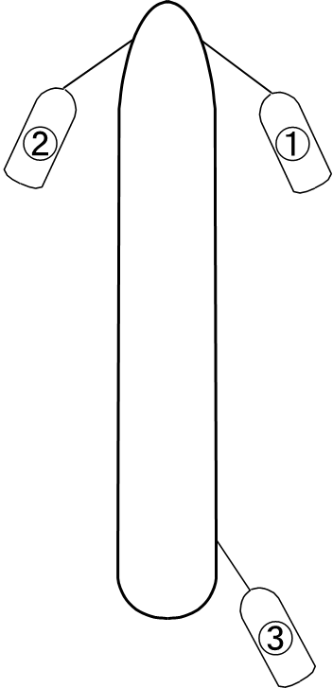
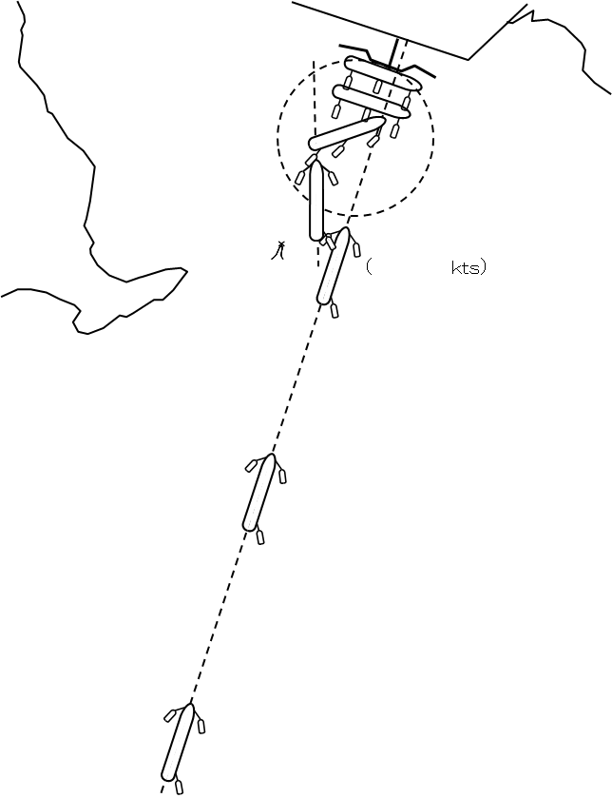
Tug boats arrangement

① ( ) PS
② ( ) PS
③ ( ) PS
④ ( ) PS
Berthing plan

Safety measures for berthing
① Recommend speed at above No.1 Buoy should be about 3kts.
② The ship’s speed should be ascertained by tug boats at proper time.
③ The ship should be made a complete and parallel stop at about 250m off the jetty.
④ Final berthing speed should be kept half distance to the jetty and the reaching speed towards dolphin
fenders should be 5cm/sec.

Plan of Tokuyama JXTG Kudamatsu K-1

Date:

Master Inland Sea Pilot

During pilotage particularly on long passage, circumstances may change which require an alteration from the information provided. And it should be borne in mind that a pilot has their own preferred way of working which may lead to variations.

CHECK LIST UNDER PILOTAGE

DATE :

SHIP’S NAME :

Voy.No

- CONFIRMATION OF SHIP’S CONDITION & EQUIPMENT
MAIN ENGINE
SHIP’S DRAFT F： (M： ) A：
WHISTLE (IF AIR SUPPLY & LOCATION)
THRUSTER IF INSTALL
STEERING GEARS UNDER OPERATION (TWO UNITS)
GYRO COMPASS (INCLUDING ERROR)
VHF RADIO (CH-15,16 & 17)
NAVIGATIONAL LIGHTS & SHAPES
OTHER NAVIGATIONAL EQUIPMENT
- CONFIRMATION OF SHIP’S MANEUVERABILITY
- REQUEST TO MASTER
LOOKOUT & MONITOR OTHER SHIP’S MOVEMENT
FIX POSITION & REPORT PILOT IT AT PROPER TIMING
MONITOR DEVIATION FROM THE ORIGINAL ROUTE
CONFIRMATION & MONITOR PILOT’S INTENTION/ORDER IF ANY DOUBT
- SHOW/LOWER THE FLAGS & SHAPES
- PRE-NOTICE TO MASTER
REDUCTION SPEED (SEA→S/B) MINUTES
CHANGE FUEL IF NECESSARY MINUTES
THRUSTER TO USE MINUTES
STATION CREW (TUG LINE , ANCHOR , BERTHING ETC.) MINUTES
ASTERN TEST
6. SEA SPEED KTS RPM
7. EXCHANGE & CONFIRMATION OF
“PILOT CARD” AND “PILOT INFORMATION CARD”
- SELF ALCOHOL CHECK BY PILOTS
BREATH ALCOHOL CONCENTRATION MEASURED IS LESS THAN 0.15mg/l.

MASTER PILOT

