(Ｈ)－2－1
For LNG carrier
SEKISAKI / HIROSHIMA
REVISED Feb. 2017
LICENSED INLAND SEA PILOT
PILOT INFORMATION CARD
Bridge Resource Management Exchange With Pilot (s)

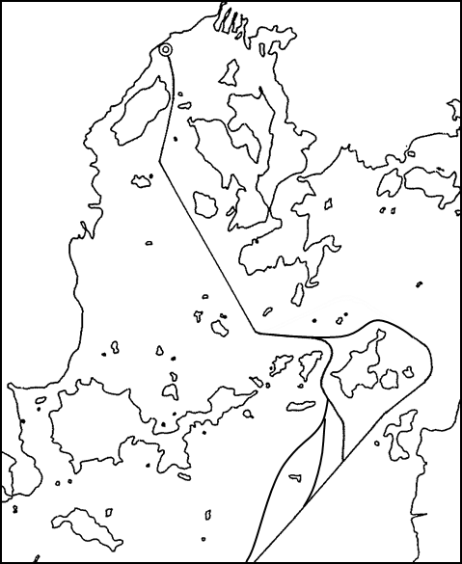
To the Master of Pilot:
Sub Pilot:

For safe navigation of your vessel you are kindly requested to:
‐ confirm the pilotage plan on this card, Name of escort boat
‐ keep a sharp lookout, ( )
‐ keep watching VHF on channel 16, and ( )
‐ put a question whenever you acknowledge a discrepancy.

Details of Passage Plan and relevant information

Rendezvous point
with escort boat&tug.
(Escort tug with fire
Fighting equip.)
(N)
(S)
KUDAKO SUIDOU
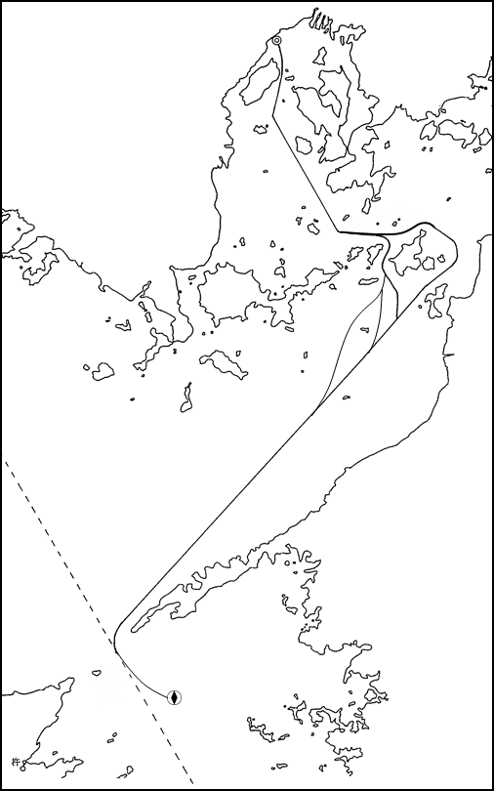
① Ship should not proceed in Hayasui Seto or
HAYASUI SETO
Hiroshima Bay, if the visibility is restricted less
(N)
(S)
than 1mile.
② Ship shall be scheduled the following speed.
below knots---in Hayasui Seto and Iyo Nada
below knots---in Kudako Suido, Hiroshima Bay

The Safety Pledge Letter should be observed.

Other Information

Berthing plan
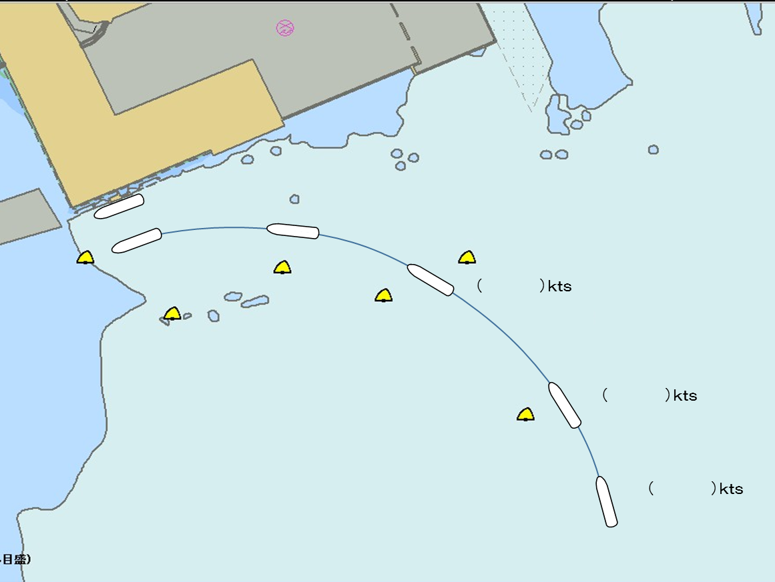
Tug boats arrangement
① ( ) PS
② ( ) PS
③ ( ) PS
④ ( ) PS

③

④

Safety Measures for berthing
① Berthing operation should be suspended when wind velocity exceeds 8m/sec and/or
visibility becomes less than 1 mile.
② All tugs should be made fast to the ship before beginning final approach to the jetty.
③ The ship should be made a complete and parallel stop 200m off the jetty.
④ In the process of pushing towards jetty, make a complete and parallel stop again about
50m off the jetty to take spring lines, fore and aft each, by line boats or messenger rope.
⑤ Berthing speed should be kept below 5cm/sec at the final stage.
⑥ Sent stern lines after the ship got alongside and it became unnecessary to use ship’s engine.
Berthing Plan of Hiroshima LNG Terminal
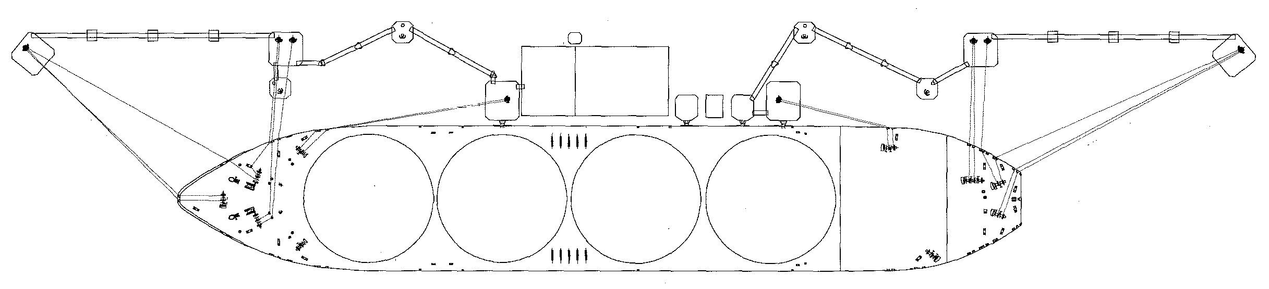

Date:

Master Inland Sea Pilot

During pilotage, particularly on long passage, circumstances may change which require an alteration from the Information provided. And it should be borne in mind that pilots have their own preferred ways of working which may lead to variations.

CHECK LIST UNDER PILOTAGE

DATE :

SHIP’S NAME :

Voy.No

- CONFIRMATION OF SHIP’S CONDITION & EQUIPMENT
MAIN ENGINE
SHIP’S DRAFT F： (M： ) A：
WHISTLE (IF AIR SUPPLY & LOCATION)
THRUSTER IF INSTALL
STEERING GEARS UNDER OPERATION (TWO UNITS)
GYRO COMPASS (INCLUDING ERROR)
VHF RADIO (CH-15,16 & 17)
NAVIGATIONAL LIGHTS & SHAPES
OTHER NAVIGATIONAL EQUIPMENT
- CONFIRMATION OF SHIP’S MANEUVERABILITY
- REQUEST TO MASTER
LOOKOUT & MONITOR OTHER SHIP’S MOVEMENT
FIX POSITION & REPORT PILOT IT AT PROPER TIMING
MONITOR DEVIATION FROM THE ORIGINAL ROUTE
CONFIRMATION & MONITOR PILOT’S INTENTION/ORDER IF ANY DOUBT
- SHOW/LOWER THE FLAGS & SHAPES
- PRE-NOTICE TO MASTER
REDUCTION SPEED (SEA→S/B) MINUTES
CHANGE FUEL IF NECESSARY MINUTES
THRUSTER TO USE MINUTES
STATION CREW (TUG LINE , ANCHOR , BERTHING ETC.) MINUTES
ASTERN TEST
6. SEA SPEED KTS RPM
7. EXCHANGE & CONFIRMATION OF
“PILOT CARD” AND “PILOT INFORMATION CARD”
- SELF ALCOHOL CHECK BY PILOTS
BREATH ALCOHOL CONCENTRATION MEASURED IS LESS THAN 0.15mg/l.

MASTER PILOT

