(Ｈ)－２－２
For LNG carrier
Sail From HIROSHIMA
REVISED Feb.2017
LICENSED INLAND SEA PILOT
PILOT INFORMATION CARD
Bridge Resource Management Exchange With Pilot (s)

To the Master of Pilot:
Sub Pilot:

For safe navigation of your vessel you are kindly requested to:
‐ confirm the pilotage plan on this card, Name of escort boat
‐ keep a sharp lookout, ( )
‐ keep watching VHF on channel 16, and ( )
‐ put a question whenever you acknowledge a discrepancy.

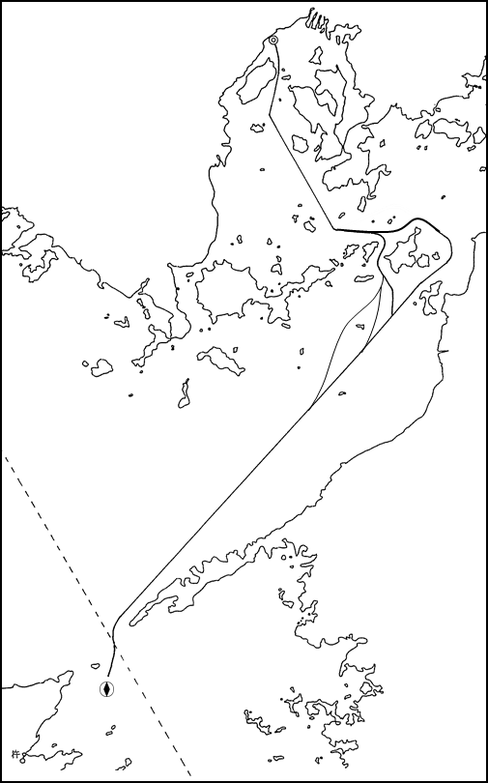
Details of Passage Plan and relevant information

Escort boat&tug.
(Escort tug with fire
Fighting equip.)
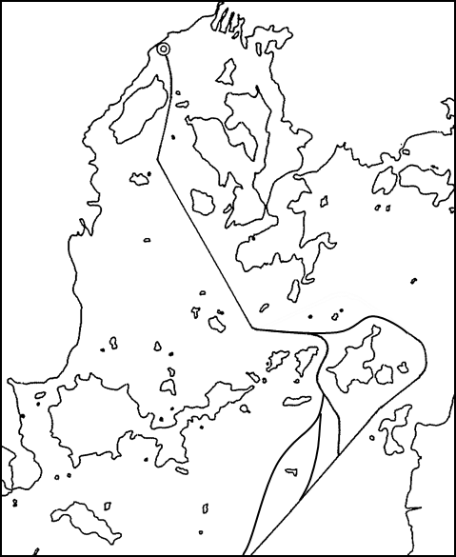
① Ship should not proceed in Hayasui Seto or
Hiroshima Bay, if the visibility is restricted less
than 1mile.
② Ship shall be scheduled the following speed.
below knots---in Hayasui Seto and Iyo Nada
below knots---in Kudako Suido, Hiroshima Bay

The Safety Pledge Letter should be observed.

Other Information

Tug boats arrangement
① ( ) PS
② ( ) PS
③ ( ) PS
④ ( ) PS

③

④

UNBERTHING PLAN
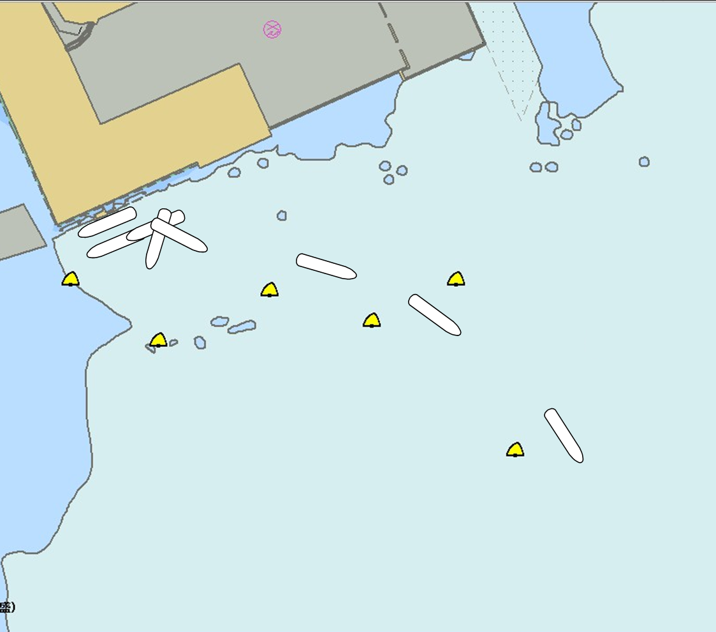





※4tug boats should be arranged when average wind velocity is between 8m/s and 10m/s.
※3tug boats should be arranged when average wind velocity is 8m/s . And/or less than 8m/s.

Safety Measures for berthing
① Unberthing operation should be suspended when average wind velocity exceeds 10m/sec and/or visibility becomes less than l mile.
② Make fast 2 tugs fore and aft on a tow line and push up to the berth together with amidships tug (no line).
③ Let go all shore lines, first head/stern lines, secondly breast lines and lastly spring lines.
④ Pull the ship by tugs bodily sideways and parallel with the berth, to about 150m off and the ship should be towed to about 0.5L east off-shore from the jetty.
⑤ Then turn the ship round 180ﾟ anticlockwise, keeping the safety distance to the berth.
⑥ When the ships heading comes to outside of the port, Increase the speed stop turning and then let go all tugs.
Plan of Hiroshima LNG Terminal

Date:

Master Inland Sea Pilot
During pilotage, particularly on long passage, circumstances may change which require an alteration from the Information provided. And it should be borne in mind that pilots have their own preferred ways of working which may lead to variations.

CHECK LIST UNDER PILOTAGE

DATE :

SHIP’S NAME :

Voy.No

- CONFIRMATION OF SHIP’S CONDITION & EQUIPMENT
MAIN ENGINE
SHIP’S DRAFT F： (M： ) A：
WHISTLE (IF AIR SUPPLY & LOCATION)
THRUSTER IF INSTALL
STEERING GEARS UNDER OPERATION (TWO UNITS)
GYRO COMPASS (INCLUDING ERROR)
VHF RADIO (CH-15,16 & 17)
NAVIGATIONAL LIGHTS & SHAPES
OTHER NAVIGATIONAL EQUIPMENT
- CONFIRMATION OF SHIP’S MANEUVERABILITY
- REQUEST TO MASTER
LOOKOUT & MONITOR OTHER SHIP’S MOVEMENT
FIX POSITION & REPORT PILOT IT AT PROPER TIMING
MONITOR DEVIATION FROM THE ORIGINAL ROUTE
CONFIRMATION & MONITOR PILOT’S INTENTION/ORDER IF ANY DOUBT
- SHOW/LOWER THE FLAGS & SHAPES
- PRE-NOTICE TO MASTER
REDUCTION SPEED (SEA→S/B) MINUTES
CHANGE FUEL IF NECESSARY MINUTES
THRUSTER TO USE MINUTES
STATION CREW (TUG LINE , ANCHOR , BERTHING ETC.) MINUTES
ASTERN TEST
6. SEA SPEED KTS RPM
7. EXCHANGE & CONFIRMATION OF
“PILOT CARD” AND “PILOT INFORMATION CARD”
- SELF ALCOHOL CHECK BY PILOTS
BREATH ALCOHOL CONCENTRATION MEASURED IS LESS THAN 0.15mg/l.

MASTER PILOT

