〔Revised July .2018〕
(W)－9
From SEKISAKI
To OITA N-2
2
LICENSED INLAND SEA PILOT
PILOT INFORMATION CARD
Bridge Resource Management Exchange With Pilot(s)

To the Master of Pilot:

H’r Pilot:
For safe navigation of your vessel, you are kindly requested to:
－confirm the pilotage plan on this card,
－keep a sharp lookout,
－keep watching VHF channel 16, and
－put a question whenever you find discrepancy.
－fix position proper interval.
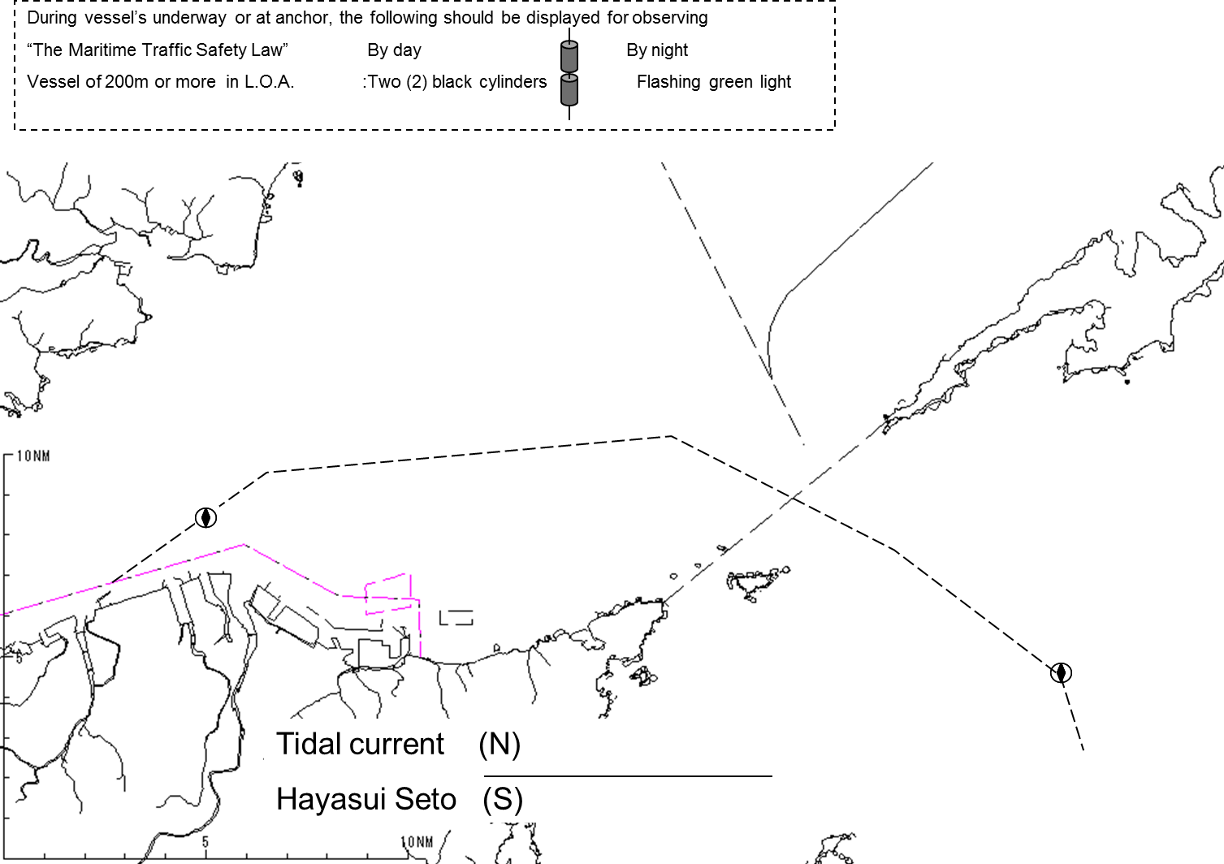
Detail of passage plan and relevant information

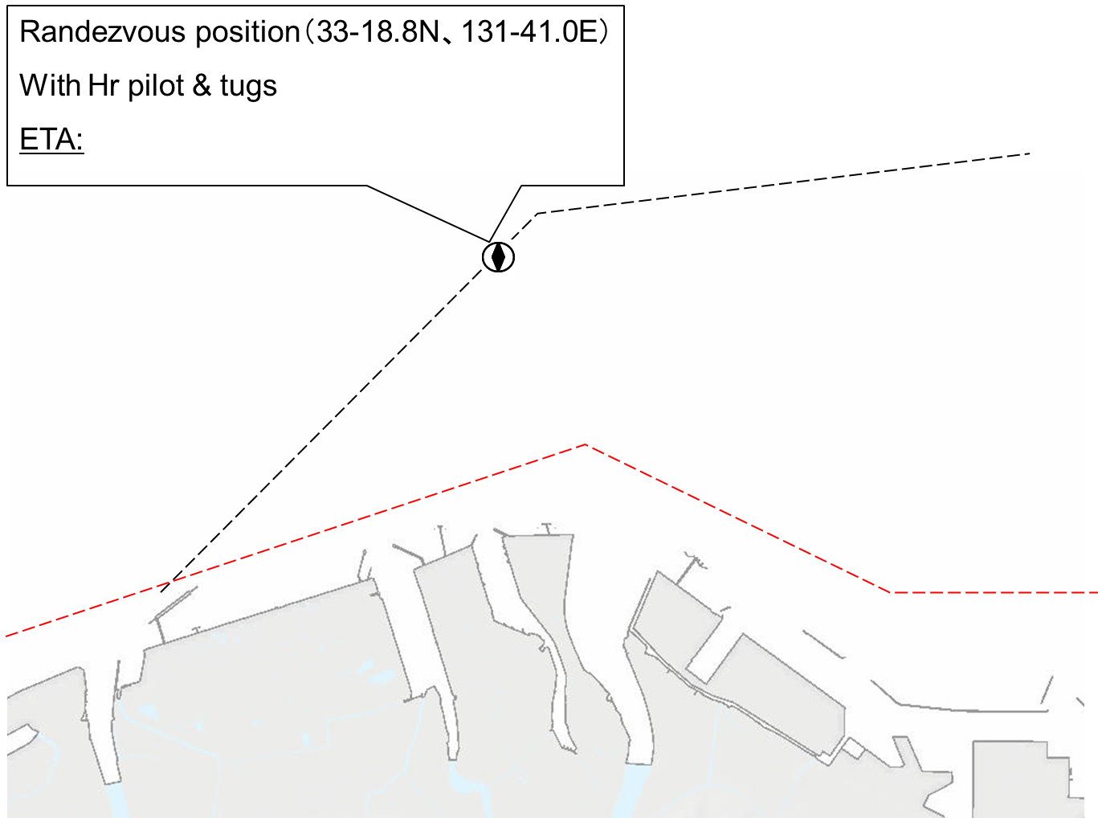

Other information

Berthing Arrangement
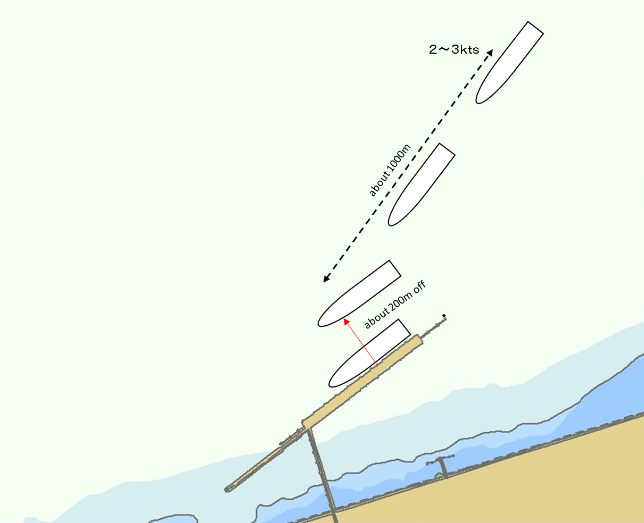
Tidal Height
（ ｃｍ）
（ ｃｍ）

Tug Boat Arrangement
(① ) PS (② ) PS
(③ ) PS (④ ) PS
(⑤ ) PS

Safety measures for berthing
①Observe ”Basic Regulation and Standard for Berthing/Un-Berthing for Nippon Steel Corporation
(NSC) Oita, Raw Material Berth, N-1 & N-2”.
②For the ship with more than 220,000DWT,in the case of night berthing,” Berthing Assistant System”
should be set by Master.
③All tugs should be made fast to the ship at about 3mile off the berth.
④Approaching speed at above 1000m from the berth should be adjust to about 2~3kts.
⑤The ship should stop parallelly at about 200m off the berth.
⑥Berthing speed should be kept less than 10cm/sec(0.2kts.) from 50m off to the berth.
⑦Berthing speed should be kept less than 5cm/sec(0.1kts.) from 10m off to the berth.

Date:

During pilotage, circumstances may change which require an alteration from the information provided. And it should be borne in mind that pilots have their own preferred ways of working which may lead to variation.
Master Inland Sea Pilot
CHECK LIST UNDER PILOTAGE

DATE :

SHIP’S NAME :

Voy.No

- CONFIRMATION OF SHIP’S CONDITION & EQUIPMENT
MAIN ENGINE
SHIP’S DRAFT F： (M： ) A：
WHISTLE (IF AIR SUPPLY & LOCATION)
THRUSTER IF INSTALL
STEERING GEARS UNDER OPERATION (TWO UNITS)
GYRO COMPASS (INCLUDING ERROR)
VHF RADIO (CH-15,16 & 17)
NAVIGATIONAL LIGHTS & SHAPES
OTHER NAVIGATIONAL EQUIPMENT
- CONFIRMATION OF SHIP’S MANEUVERABILITY
- REQUEST TO MASTER
LOOKOUT & MONITOR OTHER SHIP’S MOVEMENT
FIX POSITION & REPORT PILOT IT AT PROPER TIMING
MONITOR DEVIATION FROM THE ORIGINAL ROUTE
CONFIRMATION & MONITOR PILOT’S INTENTION/ORDER IF ANY DOUBT
- SHOW/LOWER THE FLAGS & SHAPES
- PRE-NOTICE TO MASTER
REDUCTION SPEED (SEA→S/B) MINUTES
CHANGE FUEL IF NECESSARY MINUTES
THRUSTER TO USE MINUTES
STATION CREW (TUG LINE , ANCHOR , BERTHING ETC.) MINUTES
ASTERN TEST
6. SEA SPEED KTS RPM
7. EXCHANGE & CONFIRMATION OF
“PILOT CARD” AND “PILOT INFORMATION CARD”
- SELF ALCOHOL CHECK BY PILOTS
BREATH ALCOHOL CONCENTRATION MEASURED IS LESS THAN 0.15mg/l.

MASTER PILOT

Basic Regulation and Standard for Berthing/Un-Berthing
for Nippon Steel Corporation (NSC)
Oita, Raw Material Berth, N-1 & N-2

- Berthing/Un-Berthing Standard for Weather/Sea Condition
 | Berthing/Un-Berthing Standard
 | Day Time | Night Time
Wind Speed | 15 m/s or less | 12 m/s or less
Wave Height | 1.5 m or less | 1.0 m or less
Swell | 1.3 m or less | 1.0 m or less
Visibility | 1,000m or more | 1,500 m or more

- Operation of this standard shall be considering weather forecast and discussion between, PIC of NSC OITA, Master, Pilot, Berth Master, Tug Boat, Line Handling Boat and other concerned personnel.
- “Wind Speed” means average wind speed. It shall be referring to wind speed meter equipped on the unloader at “Raw Material Berth”
- The number and arrangement of tug boats shall be followed pilot standard.
- In case of Un-Berthing under the rough weather, such as Typhoon, Conducting Un-Berthing operation within above standard.

- Determination procedure for Berthing Schedule and information scheme
- Determination procedure for Berthing Schedule
- A daily meeting held at NSC OITA will discuss and determinate berthing schedule considering with movement of the vessel, stockyard situation, shore unloading facility and ETD schedule of the vessel at berth.
- Coordinate and adjust schedule with the vessel berthing/Un-Berthing at “Slug Loading Berth”
It is prohibited to berth/Un-Berth at the same timing for “Raw Material Berth [N-1]” and “Raw Material Berth [N-2]” with adjacent “Slug Loading Berth”.
In case of scheduled Berthing/Un-berthing operation at the same timing, NSC Oita will adjust and re-determine schedule.

- Information Scheme
- Pre-notice and confirmation for berthing will inform to concerned party 3 days before berthing. It will inform again at each revision as soon as possible.
Information Scheme: NSC OITA -> Agent -> Concerned Party
- If the Berthing/Un-Berthing prospect of the vessel will be revised with any reason, inform as soon as possible.
However, revised berthing/Un-berthing prospect of the vessel is not performable due to shore reason, concerned personnel will adjust and re-arrange decision of prospect.

- Normal Operation for Berthing (Refer to Diag. No.1)
- Approaching route
- Approaching route for Berthing to N-1
- Approaching with maintaining 200m away from “Raw Material Berth”
- When passing off N-2 Berth, there is a possibility of contact with the anchor rope for oil fence expanded on the vessel berthing at N-2. Therefore, maintaining at least 80m away from oil fence.
- When berthing N-1, Turning clockwise half round, 180 degrees in front of N-1 Berth. During turning, maintaining 70m away from berth.
- During approaching, keeping adequate distance from berth with satisfying above a. & b. condition.

- Approaching route for Berthing to N-2
The vessel shall approach paralleled with N-2 Berth at 200m distance from berth and take final approach.

- Final approach & lateral approaching speed
- Take and make fast the tug line compulsory for the safety berthing.
- The lateral approaching speed is controlled within 10cm/sec or less at the position from berth with 50m.
- The lateral approaching speed is controlled within 5cm/sec or less at the position from berth with 10m.
- Controlling longitudinal speed as no head and stern.
- Conducting lateral approaching to adjust bridge front position for “N” flag at berth in parallel.
- The Berth Master inform measured distance to berth and lateral approaching speed to the Master on time.
- Berthing position
- Berthing Position
Display “N” flag on berth as the position of bridge front position.

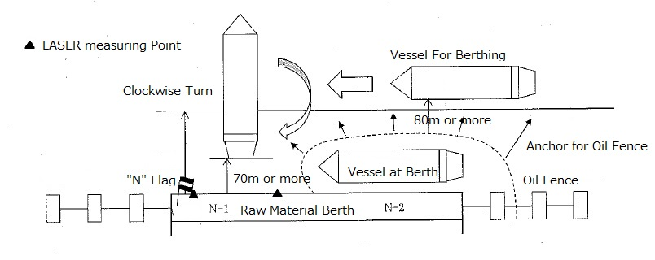
Diag. No.1 Normal Berthing Operation

- Other Remarks
- Ship crew shall heave in mooring line followed with the order by shore commander for line handling.
- The signal for permission of heaving mooring line for ship crew will be informed with shore commander’s hands up and whistle sound signal.

- Approaching Route Berthing and illumination equipment at Berth under Night Time
- Approaching Route, Final approach & lateral approaching speed
(Same as Daytime Operation)
As a heading target and guideline for approaching, one line handling boat will stand-by at the position from “Raw Material Berth” with 200m away. However, in case of the oil fence will expand to northward and the vessel shall take a distance from berth more than 200m to avoid it, the line handling boat stand-by at the position designated position and inform to the pilot in advance.
The line handling boat will stand-by at above position from the vessel reach to 2 miles from end of berth to passing the berth at her bow.

- Illumination equipment at Berth
- The illumination shall always be turned on in night.

- Name of illumination equipment
- Berth Light / Dolphin Light (Sodium Lump, Yellow)
- East end of Berth Light / East end of Dolphin Light (Sodium Lump, Yellow)
- Fender (Tube Light, Red)
- Cantilever illumination light for Unloader (White & Yellow)
- N-1 & 2 boarder indication Light 2pcs (Green)
- Passage way Light 3pcs (Mo(U) 8sec White)

- Berthing Position Light
In night time, instead of “N” flag using in day time, Display Red Signal Light on berth as the position of bridge front position.

- Night Time Berthing Assistant System
For the vessel with 220,000 DWT or more, assisted berthing operation with below;
- Supporting by Berthing Assistance System
- Measuring by Tidal Current Meter
Applicable period for Supporting: From sunset till 2 hours after sunrise.
(However, the vessel with 400,000 DWT or more is prohibited berthing/Un-berthing operation in night time.)

- Other Remarks
- Shore commander for mooring operation shall ware the Safety Illumination Vest.
- The signal for permission of heaving mooring line for ship crew will be informed with making hand signal by command tact with red light as drawing circle and whistle sound signal by shore commander.

- Special Caution for fishing Boats and Nets
Oita is a famous port as a fishing port and many fisherman conducting in vicinity of the Oita berth and quarantine anchorage. The Master shall be strictly required to avoid fishing boats and nets in the Port.
For the assistance of Masters, the NSC published fishing operation information as attached sheets. This information sheets are consisted fishing net location, operational time, details and any light and shapes for fishing boats and nets and it will be revised in seasonal as the situation. The Master can receive this information through the agent. The harbor pilot has same information, too.
Based on past statistics and analytics of location of fishing nets, the accidents which the vessel contacted fishing boats and nets in Oita ports were occurred during the anchor aweigh and pilot on board.
Therefore, the Master shall follow the below basic procedure for preventing any accidents.
- Manning adequate lookout for navigation.
- Confirmed fishing information as your navigational reference.
- Give a wide berth to boats engaged in fishing, at least 1 mile.
- Don’t pass between Green and Red flags connected on the both edge of fishing net.

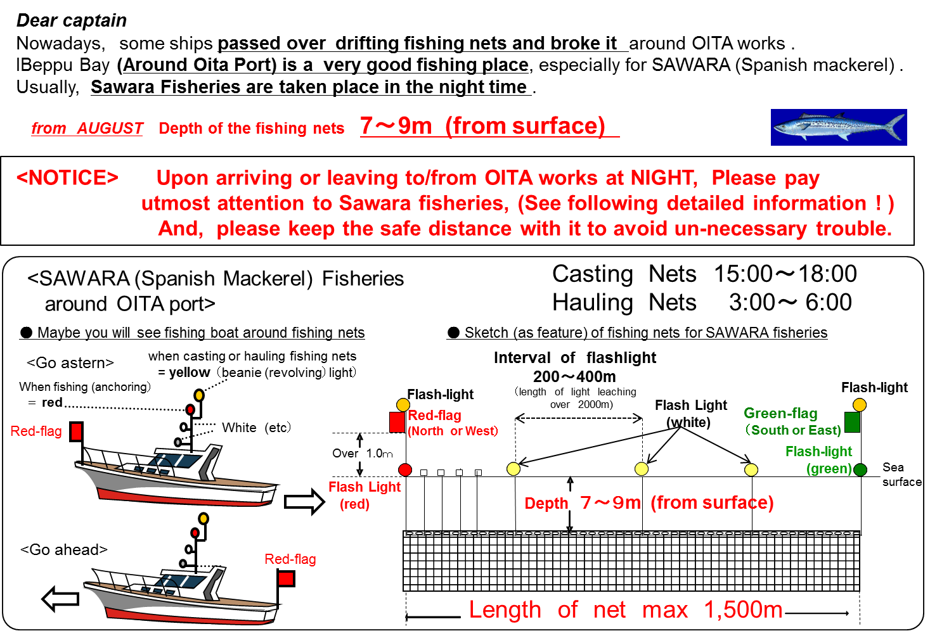
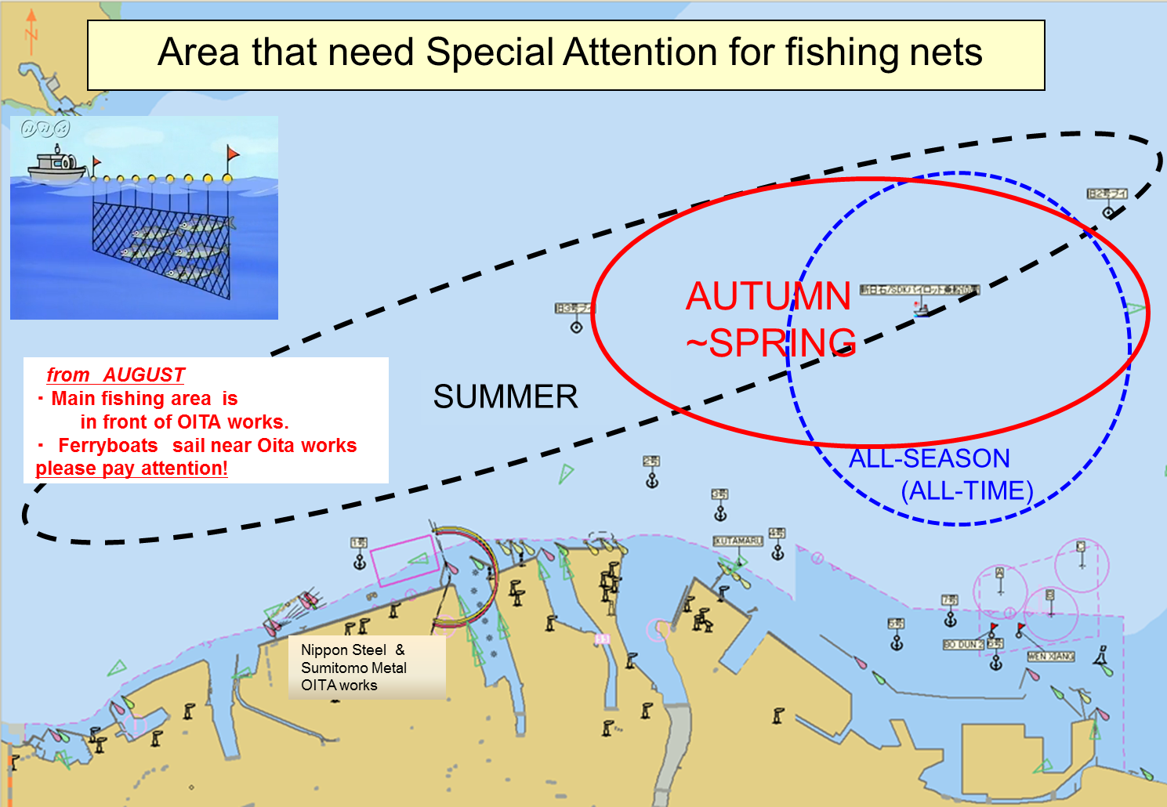
Nippon Steel
Corporation
OITA works

